**GOA UNIVERSITY**



**AI Powered Student Experience Enhancement Platform**

***A project report submitted in partial fulfillment of the requirements for the award of the degree of***

**Bachelor of Engineering in Information Technology Engineering**

***by***

**GEORGIA THERESA EDWARD VAZ**

**RAHUL MADAWALKAR**

**SIYA DEVDATT POCKLE**

***under the Guidance of***

**Ms. NADINE DIAS**

**Assistant Professor,**

**Information Technology Engineering Department**



**Information Technology Engineering Goa College of Engineering, Farmagudi, Ponda -Goa 403401**

**2024-25**

## GOA UNIVERSITY



### CERTIFICATE

This is to certify that the project report entitled

**AI Powered Student Experience Enhancement Platform** submitted by

**Georgia Theresa Edward Vaz  (Roll No: 211106084)  
Rahul Madawalkar (Roll No: 211106047)  
Siya Devdatt Pockle (Roll No: 211106064 )**

This work, conducted under my supervision during the academic year 2024-25, is a genuine endeavor. It was undertaken as a partial fulfillment of the prerequisites for obtaining the Bachelor of Engineering degree in Information Technology Engineering at Goa College of Engineering, Farmagudi, Ponda Goa, affiliated with Goa University.

Date:

Ms. Nadine Dias                                                        
 (Project Guide)

Information Technology Department

Dr. Nilesh B. Fal Dessai                                Dr. Krupashankara M. S.

(Head Of the Department)                                              (Principal)  
   Information Technology Department Goa College of Engineering

[Internal Examiner] [External Examiner]

# Acknowledgements

It gives us immense pleasure and satisfaction to present this report and to express our heartfelt gratitude to all those who have supported us throughout this project. First and foremost, we would like to extend our sincere thanks to our project guide **Ms. Nadine Dias**, for her invaluable guidance, encouragement, and support at every stage of our project. Her insights and expertise have been instrumental in shaping our work and overcoming challenges. We would also like to thank our project coordinator **Mr. Amogh Sanzgiri** for his support.

We are deeply grateful to our Head of Department, **Dr. Nilesh B. Fal Dessai**, for his unwavering support and motivation, which kept us focused and committed to our goals. We also extend our gratitude to our Principal, **Dr. Krupashankara M.S.**, for providing us with the resources and encouragement necessary for completing this project.

Lastly, we thank all the teaching and non-teaching staff, our parents, and friends, who have supported us in countless ways, directly or indirectly, throughout the course of this project. Their encouragement and assistance have been invaluable in bringing our project to fruition.

Georgia Theresa Edward Vaz

Rahul Madawalkar

Siya Devdatt Pockle

# Abstract

This project presents the development of an AI-Powered Student Enhancement Platform—a smart, modular educational assistant that leverages the capabilities of large language models, retrieval-based learning, autonomous agents, and web scraping to streamline student learning, upskilling, and opportunity access. The platform addresses key challenges in the academic ecosystem such as exam preparation, effective note-making, skill gap identification, and awareness of scholarships. It is composed of four intelligent modules: the PYQ Analyzer, which processes past year question papers using Gemini 1.5 Flash LLM to extract unit-wise important questions and frequently asked patterns; the AI Note-Making module, which uses LangChain and FAISS to retrieve syllabus-aligned textbook content and generate structured notes; the Skill Gap Analyzer, which utilizes Google’s Agent Development Kit (ADK) to recommend personalized learning paths and job-oriented skills; and the Scholarship Recommendation system, which scrapes and filters real-time scholarships based on the student’s academic profile and category.

By integrating these technologies into a single centralized platform, the system enhances the overall academic experience through automation, personalization, and intelligent decision-making. It reduces the manual workload for students, improves focus on high-priority content, identifies growth areas, and connects learners with relevant resources and opportunities. Each module is independently deployed and then linked into a unified dashboard for ease of access, ensuring both flexibility and scalability. This platform sets the foundation for a future-ready, AI-enhanced academic ecosystem that aligns with the evolving needs of modern education.

***Keywords****: Student Enhancement Platform, Past Year Question Analysis, AI Note-Making, Skill Gap Analyzer, Scholarship Recommendation, Gemini LLM, LangChain, Google ADK, FAISS, Educational AI*

# Contents

|  |
| --- |
| **Acknowledgements II** |
| **Abstract III** |
| **Contents IV** |
| **List of Figures VI** |
| **List of Tables VII** |
|  |
| **1 Introduction 8** |
| 1.1 Overview . . . . . . . . . . . . . . . . . . . . . . . . . . . . . . . . . . . . . . 8 |
| 1.2 Discussion of the problem . . . . . . . . . . . . . . . . . . . . . . . . . . . . . 8 |
| 1.3 Concept . . . . . . . . . . . . . . . . . . . . . . . . . . . . . . . . . . . . . . 8 |
| 1.4 Background . . . . . . . . . . . . . . . . . . . . . . . . . . . . . . . . . . . . 9 |
| 1.5 Motivation . . . . . . . . . . . . . . . . . . . . . . . . . . . . . . . . . . . . . 9 |
|  |
| **2 Literature Survey 10** |
| 2.1 Analysis of paper . . . . . . . . . . . . . . . . . . . . . . . . . . . . . . . . . . 10 |
|  |
| **3 Objective 13** |
| 3.1 Project objective . . . . . . . . . . . . . . . . . . . . . . . . . . . . . . . . . . 13 |
| 3.2 Project Methodology . . . . . . . . . . . . . . . . . . . . . . . . . . . . . . .14 |
|  |
| **4 Project Requirements 17** |
| 4.1 Software Requirements . . . . . . . . . . . . . . . . . . . . . . . . . . . . . 17 |
| 4.2 Technologies Used . . . . . . . . . . . . . . . . . . . . . . . . . . . . . . . 17 |
|  |
| **5 Design 18** |
| 5.1 Conceptual Design . . . . . . . . . . . . . . . . . . . . . . . . . . . . . . . 18 |
| 5.2 Detail Flow of Architecture . . . . . . . . . . . . . . . . . . . . . . . . . . 19 |
|  |
| **6 Validation & Tracing 22** |
| 6.1 Design Validation . . . . . . . . . . . . . . . . . . . . . . . . . . . . . . . . 22 |
| 6.2 Tracing of Algorithm . . . . . . . . . . . . . . . . . . . . . . . . . . . . . . 25 |
|  |
| **7 Datasets / Simulations 29** |
| 7.1 Details about dataset to be used . . . . . . . . . . . . . . . . . . . . . . . 29 |
| 7.2 Work done / testing on the dataset . . . . . . . . . . . . . . . . . . . . . . 30 |
|  |
| **8 Implementation 33** |
| 8.1 System Architecture . . . . . . . . . . . . . . . . . . . . . . . . . . . . . . 33 |
| 8.2 Configuring development environment . . . . . . . . . . . . . . . . . . . 36 |
| 8.3 Data Acquisition & Preprocessing . . . . . . . . . . . . . . . . . . . . . . 40 |
| 8.4 Application Development . . . . . . . . . . . . . . . . . . . . . . . . . . . 43 |
| 8.5 Integration . . . . . . . . . . . . . . . . . . . . . . . . . . . . . . . . . . . 47 |
|  |
| **9 Testing**  **51** |
| 9.1 Different types of testing carried out . . . . . . . . . . . . . . . . . . . . . 51 |
|  |
| **10 Results & Observation**  **59** |
| 10.1 Results . . . . . . . . . . . . . . . . . . . . . . . . . . . . . . . . . . . . . . . 59 |
| 10.2 Observation . . . . . . . . . . . . . . . . . . . . . . . . . . . . . . . . . . . 71 |
| 10.3 Future scope . . . . . . . . . . . . . . . . . . . . . . . . . . . . . . . . . . . 73 |
|  |
| **11 Conclusion**  **76** |
|  |
| **12 Bibliography**  **77** |

**List of Figures**

**Fig no.                      Title                                                                              Page No.**

5.1 Detailed flow of the Diagram AI-Powered Student 18

Experience Enhancement Platform

5.2 Activity Diagrams AI-Powered Student Experience 20

Enhancement Platform

10.1.a Data Successfully store in the database 55

10.1.b Scholarship Platform UI 56

10.1.c Previous Year Question Paper Analyser UI 56

10.1.d Note Generator Platform UI 57

10.1.e Bert Score for Relational Algebra Notes 57

10.1.f Bert Score for Global System for Mobile Communication Notes 58

10.1.g Bert Score for Satellite Systems Notes 58

10.1.h Bert Score for Types of Substitution Cipher 58

Techniques Notes

10.1.i Initial queries for identifying skill gap 59

10.1.j Successful roadmap suggestion 60

10.1.k Successful Project suggestion 61

10.1.l Successful youtube videos suggestion 62

10.1.m Successful Google search 63

10.1.n Successful courses suggestion 64

10.1.o Successful project analyses 65

10.1.p Skill Gap Analyser UI 66

10.2.a Successful GitHub Actions workflow run 67

**List of Tables**

**Fig no.                      Title                                                                              Page No.**

9.1.a Functional Testing for Scholarship Platform 52

9.1.b Functional Testing for Previous Year Question Paper Analyzer 53

9.1.c Functional Testing for AI note making 55

9.1.d Functional Testing for Skill Gap Analyser 57

**Chapter 1**

**Introduction**

**1.1 Overview**

In the rapidly evolving educational landscape, students often face challenges in navigating their academic journeys effectively. Common issues include difficulties in preparing for exams, lack of efficient tools for creating study materials, and limited awareness of skill gaps and career opportunities. Furthermore, accessing personalized scholarship information and resources to meet individual needs remains a significant hurdle. These problems are amplified in environments where traditional resources and guidance are insufficient to address diverse student requirements. The AI-Powered Student Experience Enhancement Platform addresses these challenges by leveraging advanced artificial intelligence technologies to create a comprehensive solution.

**1.2 Discussion of the Problem**

Students at Goa College of Engineering and similar institutions face various barriers in achieving academic and career success. Exam preparation is often inefficient due to limited insights into past question paper trends and patterns. Note-making, a time-consuming and crucial part of learning, lacks streamlined solutions tailored to syllabus requirements. Additionally, many students are unaware of the skill gaps between their academic achievements and industry expectations, leaving them unprepared for the job market. Limited access to personalized scholarship information further restricts their opportunities for financial support. These challenges necessitate an innovative platform to provide tailored academic assistance, career development tools, and personalized resources.

**1.3 Concept**

The AI-Powered Student Experience Enhancement Platform is conceptualized as a one-stop solution to address the multifaceted challenges faced by students. The platform integrates AI-driven tools, including a PYQ Analyzer for exam preparation, a Note-Making tool for creating efficient study materials, a Skill Gap Analyzer for career readiness, and a Scholarship Platform for personalized financial aid suggestions. By utilizing cutting-edge AI technologies such as large language models, the platform ensures a seamless and impactful user experience, empowering students to achieve their academic and professional goals.

**1.4 Background**

The idea for the platform stems from the increasing reliance on AI technologies in education and the need for tailored solutions to bridge the gap between academic learning and industry demands. Existing tools for exam preparation, note-making, and career guidance often operate in silos, failing to provide a cohesive and comprehensive experience. This project draws inspiration from advancements in large language models and their ability to process and generate contextually relevant information, leveraging them to create a unified platform that addresses students' diverse needs effectively.

**1.5 Motivation**

The motivation behind this project is rooted in the desire to empower students by addressing their most pressing academic and career challenges. Observing the difficulties faced by peers in exam preparation, note-making, and skill development inspired the development of a platform that leverages AI to simplify these processes. Furthermore, the project aims to bridge the gap between students' aspirations and available resources, ensuring they have access to tools and information that can enhance their academic performance and career prospects. By integrating advanced technologies into a user-friendly application, the project seeks to make a meaningful impact on the student community.

**Chapter 2**

**Literature Survey**

**2.1 Analysis of paper**

**a)** **Robust Multi Model RAG Pipeline For Documents Containing Text, Table & Images**

Pankaj Joshi, Aditya Gupta, Pankaj Kumar, Manas Sisodia (2024), 3rd International Conference on Applied Artificial Intelligence and Computing (ICAAIC)

Retrieval-Augmented Generation (RAG) is a powerful approach that enhances the effectiveness of language models by combining retrieval mechanisms with generative capabilities. The study focuses on a robust multimodal RAG pipeline designed to process documents containing both text and images. A major challenge addressed in this research is the difficulty existing RAG systems face in understanding the complex relationships between text and visual elements in documents. By introducing a novel multimodal pipeline, the study ensures that both data types are accurately retrieved and utilized, leading to improved question-answer generation. Testing across different question formats—short-form, long-form, multiple-choice, and true/false—revealed significant improvements in precision and relevance, showcasing the pipeline's potential for educational applications.

Additionally, the proposed pipeline was compared against leading multimodal large language models like OpenAI and Gemini, demonstrating superior performance in various scenarios. The system's effectiveness stems from its ability to integrate and analyze multimodal data, which is essential for educational use cases involving textbooks, presentations, and other rich-media resources. This research emphasizes the importance of tailoring RAG pipelines to educational contexts, enabling better student outcomes by providing relevant and accurate learning materials.

#### **b) Question Generation from PDF using LangChain**

Dinesh Madhav, Sanskruti Nijai, Urvashi Patel, Komal Champanerkar (2024), 11th International Conference on Computing for Sustainable Global Development (INDIACom)

The study on automated question generation leverages the LangChain framework, a natural language processing (NLP) tool, to create meaningful and well-structured questions from PDF documents. By extracting named entities, relationships, and important concepts, the system ensures that the generated questions are contextually relevant and aligned with the content. This method revolutionizes the way educators and students interact with study materials by providing diverse questions across various cognitive levels. Whether short-answer, long-form, or critical thinking questions, the system generates content that supports active learning and enhances comprehension.

Furthermore, the integration of contextual awareness and knowledge patterns in question generation ensures a deeper engagement with the material. The research highlights the scalability of this approach, as it can be applied to a wide range of educational documents, from textbooks to exam papers. By automating the process of question creation, this study significantly reduces the workload on educators and enables students to better evaluate their understanding of the subject matter. The potential for integrating feedback systems and advanced cognitive-level questions in future iterations opens new avenues for enhancing educational outcomes.

**c) Constructing the ChatGPT for PDF Files with Langchain – AI**

Dr.T. Prem Jacob, Dr. Beatriz Lucia Salvador Bizotto, Dr Mithileysh Sathiyanarayanan (2024), International Conference on Inventive Computation Technologies (ICICT)

This paper introduces a solution for efficiently querying and extracting information from unstructured PDF documents using LangChain, a framework integrated with large language models (LLMs) like GPT. It tackles the challenge of retrieving contextually accurate information from PDFs by employing semantic search powered by transformer-based models. Unlike traditional keyword-based search systems, the approach leverages embeddings to represent document content in vector form, enabling efficient query processing. Large PDFs are chunked into manageable segments, with embeddings generated for each chunk to ensure compatibility with LLM token limits. The use of Streamlit for building a user-friendly interface enhances accessibility, allowing users to upload PDFs and interact with the content through natural language queries. The system supports advanced generative capabilities, including question answering and summarization, by utilizing similarity scoring with embeddings.

The findings reveal a significant improvement in precision and relevance of search results compared to conventional systems. LangChain's combination of semantic search, chunking, and embeddings enables scalable information retrieval, even for large datasets. The framework's utility is demonstrated through its ability to process complex queries and generate meaningful responses. This innovative tool is applicable across various domains, such as legal, educational, and research contexts, where efficient analysis of PDF content is crucial. By simplifying and enhancing the querying process, the paper highlights the potential of LangChain-based systems in transforming document analysis and retrieval tasks. The authors conclude that this integration of NLP frameworks and LLMs represents a milestone in making unstructured data more accessible and usable for users.

**d) Self-Adaptive Large Language Model (LLM)-Based Multiagent Systems**

Nathalia Nascimento, Paulo Alencar, Donald Cowan (2023), IEEE International Conference on Autonomic Computing and Self-Organizing Systems Companion (ACSOS-C)

This paper explores the integration of GPT-4 into Multiagent Systems (MASs) to enhance their adaptability, decision-making, and communication capabilities in dynamic environments. The study leverages the MAPE-K model (Monitor, Analyze, Plan, Execute, and Knowledge), modifying it to include GPT-4 for improved reasoning and responsiveness. Agents are equipped with GPT-4 to process sensor data, generate intelligent responses, and adapt to changing scenarios in real-time. A simulated e-commerce marketplace was used as a case study, where autonomous agents acted as buyers and sellers, negotiating prices and making strategic decisions. Agents exhibited emergent behaviors, such as proactive negotiation and adaptive problem-solving, highlighting the system's ability to manage complex, real-world interactions.

The findings showcase the effectiveness of LLM integration, with agents demonstrating advanced decision-making and collaborative behaviors. Challenges such as managing token limits and interaction history were identified, emphasizing the need for supplementary components like local memory and planning modules. The study also observed unforeseen agent behaviors, indicating the potential for creative problem-solving and adaptability. The authors conclude that embedding LLMs into MASs represents a paradigm shift in self-adaptive systems, enabling intelligent interactions and dynamic adaptability. Future directions include exploring non-shared AI models, human-in-the-loop interactions, and broader applications in fields like robotics and IoT. This work underscores the transformative potential of LLMs in revolutionizing MAS design and functionality.

**Chapter 3**

**Objective**

**3.1 Project Objective**

**3.1.1 Previous Year Question Paper Analyzer**

The primary objective of the PYQ Analyzer module is to simplify and enhance the exam preparation process for students by leveraging the power of artificial intelligence. This tool is designed to intelligently analyze past year question papers (PYQs) and extract unit-wise important topics and frequently repeated questions, enabling focused and efficient study. Traditional methods of manually going through old papers are time-consuming and prone to oversight. By automating this task using a Large Language Model (Gemini 1.5 Flash), the PYQ Analyzer ensures accurate and structured insights in real-time. The ultimate aim is to empower students with data-driven preparation strategies, helping them concentrate on high-weightage areas and improve academic outcomes.

**3.1.2 Scholarship Platform**

The primary objective of this project is to develop and implement a robust, automated platform designed to efficiently acquire, process, and manage comprehensive scholarship information from diverse online sources. This initiative aims to address the significant challenge faced by students in accessing timely and relevant scholarship opportunities due to the fragmented and dynamic nature of available information. By centralizing and continually updating a structured database of scholarships, the platform seeks to reduce the manual effort currently required for data collection, enhance the accuracy and freshness of scholarship details, and ultimately facilitate easier access for prospective applicants. The platform is engineered for high data quality, operational efficiency, and future scalability, ensuring it remains a valuable and up-to-date resource.

**3.1.3 AI Note Generator**

The objective of this project is to develop an intelligent note generation system that automates the creation of concise, syllabus-aligned academic notes from textbook content. The system is designed to assist students and educators by minimizing manual effort in summarizing large volumes of subject matter. By leveraging semantic chunking, vector embeddings, similarity search, and large language models, the system The development of the Note Generator system followed a structured methodology focused on modular design and iterative validation. The process began with data acquisition, where subject-specific textbooks were collected and processed to extract clean textual content. This content was then semantically segmented using a custom chunking pipeline powered by the Gemini 2.0 Flash model, which identified thematically coherent boundaries within the material.

Each semantic chunk was embedded using the GoogleGenerativeAIEmbeddings model and stored in a FAISS vector database to enable efficient similarity-based retrieval. When a user inputs a subject and topic, the system performs a vector similarity search to fetch the most relevant chunks. These retrieved segments are passed to the Gemini 1.5 Pro LLM, which generates concise, structured notes grounded in the textbook content.

To ensure scalability and user accessibility, the backend was hosted on Hugging Face and the frontend on Vercel. The system was tested extensively for coherence, semantic accuracy, and response relevance using qualitative review and BERTScore evaluation. This end-to-end methodology enabled the reliable transformation of textbook data into contextually rich academic notes with minimal user input.

aims to deliver accurate, well-structured notes based on minimal user input—limited to subject name and topic. The overall goal is to enhance the learning process by providing easily accessible, contextually relevant study material derived directly from textbooks.

**3.1.4 Skill Gap Analyzer**

The primary objective of the Skill Gap Analyzer project is to empower individuals by providing a personalized and intelligent conversational platform for identifying and addressing their skill development needs. This system aims to go beyond generic recommendations by leveraging advanced AI capabilities to understand a user's current academic and professional profile, specific interests, and declared skills. By doing so, it can accurately pinpoint knowledge and skill deficiencies. The ultimate goal is to facilitate continuous learning and career growth through the provision of tailored learning resources, including relevant online courses, structured project ideas with implementation guidance, actionable feedback on code submitted via GitHub, and visual career roadmaps, thereby bridging the gap between an individual's current capabilities and their future aspirations in the dynamic technological landscape.

**3.2 Project Methodology**

**3.1.1 Previous Year Question Paper Analyzer**

The development of the PYQ Analyzer module follows a modular and AI-driven methodology. The process begins with the user uploading a PDF of a past year question paper through a React-based frontend. This file is then processed in the backend using PyMuPDF or similar tools to extract and clean the text content. The cleaned questions are segmented and converted into a prompt that is fed to the Gemini 1.5 Flash LLM, which analyzes the questions to identify patterns, repetitions, and topic clusters. The output generated by the LLM is parsed, formatted, and sent back to the frontend, where it is displayed in a chat-based interface for further interaction. Each component is developed and deployed independently, ensuring modularity and scalability. The module is hosted using Cloudflare Pages and integrated into the main platform dashboard via secure hyperlinks, maintaining consistency across the entire student enhancement system.

**3.1.2 Scholarship Platform**

The project adopted an iterative and component-based methodology to ensure systematic development and continuous validation. Initially, a comprehensive requirement gathering phase defined the scope, target data fields, and desired automation level. This was followed by a strategic design phase, outlining the system architecture, selecting core technologies such as Python for development, Selenium and Playwright for web automation, ScrapegraphAI powered by the Gemini LLM for intelligent data extraction, and MongoDB for flexible data storage. Design validation was performed through feasibility studies and architectural reviews to confirm the technical viability of these choices. The implementation phase focused on modular development, beginning with the creation of specialized scripts for dynamic link discovery from key portals like Vidyasaarathi and Buddy4Study. Concurrently, the core application logic was developed to leverage ScrapegraphAI for detailed scholarship data extraction, followed by robust data preprocessing routines for cleaning, standardization, and crucial date parsing. Automation was a central tenet, with GitHub Actions configured to orchestrate the entire pipeline—from scheduled scraping and processing to secure credential management and automated deployment. Throughout development, a multi-layered testing strategy, encompassing unit, integration, functional, data quality, and robustness testing, was rigorously applied to validate each component and ensure data integrity. Finally, a dedicated cleanup mechanism was implemented to maintain the database's relevance by automatically removing expired scholarship records, ensuring the platform consistently provides fresh and actionable information.

**3.1.3 AI Note Generator**

The development of the Note Generator system followed a structured methodology focused on modular design and iterative validation. The process began with data acquisition, where subject-specific textbooks were collected and processed to extract clean textual content. This content was then semantically segmented using a custom chunking pipeline powered by the Gemini 2.0 Flash model, which identified thematically coherent boundaries within the material.

Each semantic chunk was embedded using the GoogleGenerativeAIEmbeddings model and stored in a FAISS vector database to enable efficient similarity-based retrieval. When a user inputs a subject and topic, the system performs a vector similarity search to fetch the most relevant chunks. These retrieved segments are passed to the Gemini 1.5 Pro LLM, which generates concise, structured notes grounded in the textbook content.

To ensure scalability and user accessibility, the backend was hosted on Hugging Face and the frontend on Vercel. The system was tested extensively for coherence, semantic accuracy, and response relevance using qualitative review and BERTScore evaluation. This end-to-end methodology enabled the reliable transformation of textbook data into contextually rich academic notes with minimal user input.

**3.1.4 Skill Gap Analyzer**

The development of the Skill Gap Analyzer followed an agile and iterative methodology, emphasizing modularity and integration, largely driven by the Google Agent Development Kit (ADK). The process began with a clear definition of requirements, leading into a phased design approach that emphasized a multi-agent architecture. Core to the methodology was the development of specialized LlmAgents, each with distinct responsibilities (e.g., project suggestion, code analysis), guided by meticulously crafted prompt instructions and powered by Google Gemini models. These agents interact seamlessly with a suite of custom FunctionTools, developed in Python, which encapsulate specific functionalities such as querying external APIs (YouTube, Cloudinary, Google Search) and interacting with various databases (MongoDB for course content and vector embeddings, NeonDB for persistent session and user profile management). Data acquisition for course recommendations involved preprocessing through the generation of vector embeddings using Gemini's embedding models, followed by ingestion into MongoDB with optimized vector search indexing. Throughout the development lifecycle, rigorous unit, integration, and functional testing were performed to ensure the reliability of individual components and the overall system's coherence. This iterative feedback loop of design, implementation, and testing allowed for continuous refinement, ensuring the system's effectiveness in providing accurate, relevant, and personalized skill development guidance.

**Chapter 4**

**Project Requirements**

**4.1 Software Requirements**

Programming Language:

Python

Libraries for PDF Processing:

PyPDF2

PyMuPDF

Libraries for Text Embedding:

SentenceTransformers

Database: MongoDB for storing and retrieving text and embeddings.

Web Frameworks: Next.js, JavaScript, React, TypeScript

Flask or FastAPI for backend development.

**4.2 Technologies Used**

Large Language Model: Gemini 1.5 with Mixture of Experts (MoE) architecture for efficient and scalable processing.

Task Chaining Framework: LangChain for creating agents and chaining tasks.

Multimodal Technology: Mu-RAG (Multimodal Retrieval-Augmented Generation) for processing text and image relationships.

Vector Database: For storing content embeddings and facilitating efficient retrieval.

Web Scraping Tools: scrape-graph-AI for aggregating data for skill gap analysis and scholarships.

Instruction-Tuning: To adapt the pre-trained models for specific tasks.

**Chapter 5**

**Design**  
  
  **5.1 Conceptual Design**

The conceptual design of the AI-Powered Student Enhancement Platform focuses on building an intelligent and modular system that integrates multiple AI capabilities to enhance student learning, skill development, and access to opportunities. The platform is designed around four key modules: PYQ Analyzer, AI Note-Making, Skill Gap Analyzer, and Personalized Scholarship Recommendation.

Each module addresses specific pain points faced by students and leverages the power of LLMs, vector databases, and retrieval-augmented systems to ensure a highly personalized experience.

Key Design Principles:

* Modularity: Each component is self-contained and loosely coupled, allowing easy integration and updates.
* Scalability: Designed using scalable frameworks like Flask and React, ensuring the platform can handle increasing user demands.
* Personalization: Uses LLMs and vector similarity to tailor content and recommendations to individual students.
* Automation: Automates time-consuming academic tasks like note-making, exam analysis, and scholarship discovery.

Module-Wise Overview:

* PYQ Analyzer: Accepts past question papers as input, processes them using Gemini 1.5 Flash LLM to find repeated patterns, and outputs unit-wise important questions/topics.
* AI Note-Making: Uses LangChain + FAISS to retrieve syllabus-relevant content from textbooks and generate structured notes.
* Skill Gap Analyzer: Employs Google ADK to create autonomous agents that recommend learning paths, web resources, and job-oriented skills.
* Scholarship Recommendation: Uses BeautifulSoup to scrape real-time scholarships, filtered based on user criteria like academic domain and category.

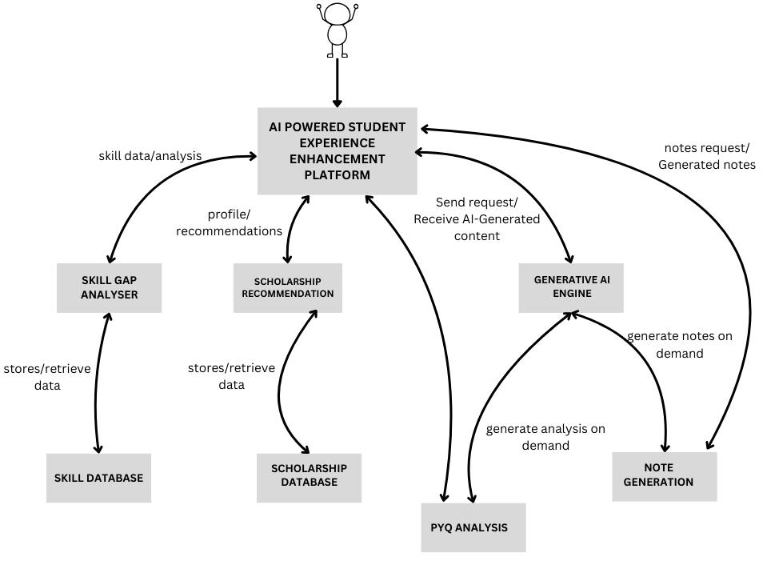

Figure 5.1: Detailed flow of the Diagram AI-Powered Student Experience Enhancement Platform

**5.2 Detail Flow of Architecture**

### The architecture of the AI-Powered Student Enhancement Platform is modular, scalable, and integrates state-of-the-art AI technologies. It follows a microservice-like architecture where each functional module operates independently yet cohesively under a unified interface. The system primarily comprises the Frontend Interface, Flask-based Backend API Layer, LLM Services, Vector Databases, Agents, and Scraping Tools.

### 5.2.1. Previous Year Question Analyzer Module

### Objective: Analyze past year question papers and generate unit-wise important topics.

### Step 1: User uploads PDF of past question papers and syllabus via frontend.

### Step 2: Backend receives the file, extracts and understands text from pdf.

### Step 3: The extracted text is sent to the Gemini 1.5 Flash LLM using an API call.

### Step 4: The LLM analyzes question patterns, repetition, and frequency per unit.

### Step 5: The system returns a structured output: Unit -> Important Topics.

### 

### 5.2.2. AI Note Generator Module

Objective: Generate syllabus-aligned notes from textbooks using RAG.

Step 1: User inputs a syllabus topic via the UI.

Step 2: Pre-processed textbook chunks(Semantic chunking) are already embedded using SentenceTransformers and stored in FAISS Vector Database.

Step 3: LangChain queries the vector DB with the topic to retrieve top-k relevant chunks.

Step 4: Retrieved chunks are passed to Gemini 1.5 Flash to generate coherent and structured notes.

Step 5: Final notes are formatted and displayed/downloadable for the user.

### 5.2.3. Skill Gap Analyzer Module

Objective: Identify gaps between user’s current skills and industry/job requirements and recommend personalized resources.

Step 1: User submits current skills and target domain (e.g., Data Science).

Step 2: Google ADK orchestrates agents with access to external tools (e.g., YouTube API, job role datasets, course APIs).

Step 3: Agents fetch skill requirements for the selected domain.

Step 4: Compare user’s skillset with industry requirements.

Step 5: Recommend roadmaps, online courses, videos, or GitHub repos tailored to the gap.

### 5.2.4. Scholarship Recommendation Module

Objective: Display relevant scholarships based on user profile and eligibility.

Step 1: User profile data (course, category, state, etc.) is submitted through the frontend.

Step 2: Flask backend triggers the BeautifulSoup-based scraper.

Step 3: The scraper collects current scholarship listings from multiple verified sources (e.g., NSP, Buddy4Study).

Step 4: Data is filtered based on user profile.

Step 5: Matched scholarships are displayed with links and eligibility info.

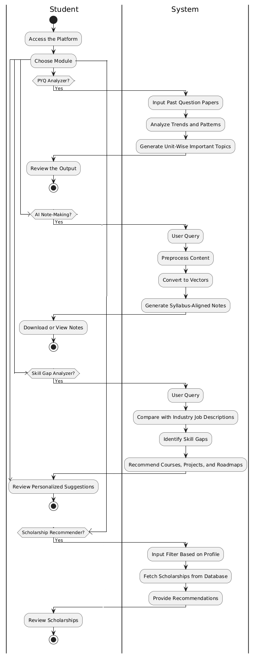

Figure 5.2: Activity Diagrams AI-Powered Student Experience Enhancement Platform

**Chapter 6**

**Design Validation & Tracing**

**6.1 Design Validation**

**6.1.1 Scholarship Platform**

The design phase focused on ensuring the system's architecture and component choices met all requirements and were technically feasible.

* Requirements Alignment: The design was continuously checked against functional (e.g., automated data collection, specific data fields) and non-functional (e.g., robustness, data freshness) requirements.
* Feasibility & PoC: Key technologies like Selenium, Playwright, scrapegraphai, and MongoDB were validated through small Proofs of Concept (PoCs) to confirm their ability to handle dynamic websites, extract data accurately via LLM, and store flexible schemas.
* Schema & Security Review: The MongoDB schema was reviewed for completeness and optimization, and secure credential management via GitHub Secrets was validated.

**6.1.2 Previous year Question Paper Analyser**

The design of the PYQ Analyzer module has been validated through extensive testing to ensure that it meets the intended functional and performance requirements. The primary goal of the module is to analyze past year question papers provided in PDF format and generate unit-wise important topics and repeated patterns using AI-powered insights.

To validate the design, various test scenarios were executed, including uploading different PDF formats, evaluating text extraction accuracy, prompt effectiveness, and the quality of responses generated by the integrated Gemini 1.5 Flash LLM. The user interface was also tested to ensure smooth interaction and response handling in a chat-like environment.

The PDF parser was found to effectively extract question data from standard academic documents. The integration with the Gemini API was validated by sending multiple real-world prompts and reviewing the relevance and structure of the returned data. Through these validations, it was confirmed that the system can consistently provide accurate, unit-wise breakdowns of frequently asked questions, thereby aligning well with the academic needs of the user.

In addition, the chat interface was tested for usability, responsiveness, and its ability to handle contextual follow-up queries, such as "Which topics are most frequently asked in Unit 3?" or

"Which unit has the highest question density?" The system performed reliably under all tested scenarios, confirming that the design is functional, scalable, and user-centric.

**6.1.3 AI Note Generator**

* Semantic Chunking Validation

To ensure that textbook content is split into thematically coherent and meaningful units, the semantic chunking process was rigorously validated. Using the Gemini 2.0 Flash model, the system pre-segmented content into token-based chunks, which were then reorganized into semantically consistent sections. Manual inspection of these final chunks was conducted to confirm logical flow and thematic completeness. The LLM's ability to detect topic transitions, such as new headings or conceptual shifts, was evaluated, and the resulting chunks were found to be self-contained, well-structured, and ideal for downstream embedding and note generation.

* Embedding Quality Validation

The quality of the embeddings, which form the basis of the semantic search mechanism, was validated to ensure that they accurately captured the contextual meaning of the content. The system used GoogleGenerativeAIEmbeddings (embedding-001) to convert chunks into vector representations. These embeddings were stored in a FAISS vector store, and similarity searches were performed based on user-provided queries. The relevance and accuracy of the retrieved content were assessed by comparing the outputs with the original textbook material. Results showed that the embeddings retained strong semantic alignment, enabling effective and meaningful retrieval.

* Query-to-Notes Relevance

A critical aspect of the system was validating whether the generated notes truly reflected the user's input queries and the context of retrieved textbook content. Multiple subject-topic combinations were tested, and the system’s outputs were reviewed for alignment with the curriculum, conceptual clarity, and detail. The Gemini 1.5 Pro model effectively synthesized well-structured, coherent notes from the retrieved content. The outputs demonstrated a high degree of relevance, showing the system's ability to convert vector-retrieved academic material into usable, syllabus-aligned study notes.

* Rate Limiting and Fault Tolerance

To ensure system reliability during API interactions, especially under quota constraints, a robust rate limiting and fault tolerance mechanism was developed. The Gemini API client included built-in retry logic and request caching along with time-based throttling. Extensive testing was done to simulate conditions such as API rate limit exceedance and connection drops. The system successfully recovered from such scenarios using checkpoint-based resumption without reprocessing previously completed sections, thereby ensuring resilience and efficiency.

* Storage and Retrieval Integrity

The integrity of the chunked data and vector embeddings was validated through repeated storage and retrieval operations. Each chunked file and its corresponding vector were stored in structured directories for each subject and textbook. Retrieval queries were executed multiple times to confirm consistency in results. The system reliably mapped stored vector representations back to their source content, confirming that the indexing and chunking mechanisms were stable and accurate over time.

* System Performance and Scalability

Finally, the system was validated for performance and scalability across diverse textbook sizes and subject areas. It was tested with multiple PDFs per subject, ranging from a few hundred pages to over a thousand. Performance metrics such as processing time, memory usage, and response latency were observed. The system demonstrated efficient memory handling and maintained stable output quality even for large inputs. This confirmed the design’s ability to scale for broader academic use involving multiple courses and departments.

**6.1.4 AI Skill Gap Analyzer**

The validation process for the Skill Gap Analyzer's design included:

* Requirements Traceability Matrix (RTM) Review: A thorough review of the RTM was conducted to ensure every identified functional and non-functional requirement had a corresponding design element. This helped confirm that no requirement was overlooked and that the design adequately supported all desired functionalities, such as identifying skill gaps, suggesting projects, recommending courses, and providing roadmaps.
* Architectural Review: The overall system architecture, including the interaction between the ADK (Agent Development Kit) agents (e.g., ProjectSuggestionAgent, GitHubAnalysisAgent, SearchAgent), the MongoDB database for courses, the session management via NeonDB, and external APIs like YouTube and Cloudinary, was meticulously reviewed. This validation checked for logical consistency, scalability, security considerations, and potential bottlenecks. For example, ensuring that the recommend_courses_from_db tool correctly integrated with MongoDB's vector search capabilities was a critical validation point.
* Data Model Validation: The design of the data models for user profiles, course information, and stored project suggestions was validated. This involved checking for data integrity, appropriate data types, relationships between entities, and efficiency of storage and retrieval, especially for vector embeddings used in course recommendations.
* Tool Interface Validation: Each FunctionTool (e.g., search_youtube_tool, recommend_courses_tool, update_user_profile_tool) was validated to ensure its input parameters, output structures, and error handling mechanisms were clearly defined and aligned with the expectations of the agents using them. This ensured seamless communication and data exchange between the agents and their respective functionalities.
* User Flow Walkthroughs: Simulated user scenarios were walked through using the design. For instance, a scenario where a user asks for project suggestions, then submits code for analysis, was traced through the design to confirm that the ProjectSuggestionAgent correctly saves project data, and the GitHubAnalysisAgent can then retrieve it, demonstrating the intended workflow and data persistence.
* Security and Privacy Considerations: The design was validated against potential security vulnerabilities, particularly regarding API key management (e.g., GOOGLE_API_KEY, YOUTUBE_API_KEY) and the handling of user data stored in the session and MongoDB. This ensured that sensitive information was protected and access was appropriately controlled.

**6.2 Tracing of Algorithm**

**6.2.1 Scholarship Platform**

This section outlines the logical flow of the platform's primary operations:

* Scholarship Data Acquisition & Processing:
  1. Trigger: Initiated by GitHub Actions.
  2. Link Collection: Gathers scholarship URLs from Vidyasaarathi, Buddy4Study (using Selenium/Playwright), and staticlinks.json.
  3. Iterative Processing: For each unique link:
     + scrapegraphai (with Gemini LLM) extracts raw structured data from the web page.
     + Data is preprocessed, including date parsing (parse_date_string) and standardization.
     + Processed data is upserted (inserted or updated) into MongoDB, using source_link for uniqueness.
     + Errors are logged to failed_links.json.
* Expired Scholarship Cleanup:
  1. Trigger: Initiated by GitHub Actions.
  2. Database Query: Identifies all scholarships in MongoDB where parsed_deadline is earlier than the current UTC time.
  3. Deletion: Removes these expired records from the database.

**6.2.2 Previous year Question Paper Analyser**

The PYQ Analyzer workflow follows a modular and traceable logic pipeline from PDF input to AI-generated output. Below is a detailed breakdown of the algorithmic flow and tracing steps.

Step-by-Step Tracing

File Upload

The user uploads a PDF document containing the past year question paper.

The system accepts the file via the frontend interface (React-based).

PDF Text Extraction

The backend uses a PDF parsing library (e.g., PyMuPDF or pdfjs) to extract raw text.

The text is cleaned to remove noise such as page numbers, headers, and unwanted symbols.

Question Segmentation

Extracted text is tokenized and segmented into individual questions.

Patterns like numbering (Q1., 1), etc.) are used to identify separate entries.

Prompt Construction for LLM

A dynamic prompt is built:  
 “Analyze the following past year question paper. Identify unit-wise important topics and highlight any frequently repeated questions.”

The segmented questions are appended below this prompt.

Gemini LLM API Call

The constructed prompt is sent to Gemini 1.5 Flash via REST API.

The model processes the input and returns structured insights:

Unit-wise question classification.

Frequency patterns of questions/topics.

Estimated importance based on repetition and question type.

Response Handling

The AI response is parsed and formatted into readable blocks:

Lists or tables categorized by unit.

Highlighted repeated questions with year-wise frequency.

Chat-Based Display

The frontend displays the AI response in a conversational format.

Users can interact further by asking follow-up queries for clarification or topic deep-dives.

**6.2.3 AI Note Generator**

### Text Extraction from PDF

The first stage in the algorithm involves extracting raw text from PDF textbooks. Each subject contains one or more textbooks in PDF format, and text is extracted using PyPDFPlumber, which efficiently handles text layout and font encodings. The extracted content is passed to the chunking module for further processing. To trace this stage, log statements are included to print file names, extraction time, and text length, ensuring that all pages are successfully parsed before proceeding.

### Pre-Chunking Based on Token Length

After text extraction, the content is divided into smaller pre-chunks based on token count using the RecursiveTokenChunker. This ensures that each chunk remains within a manageable size limit (e.g., 1000 tokens), with overlaps for context continuity. During tracing, each pre-chunk is assigned a unique identifier (e.g., <|start_chunk_X|>) to help in tracking and debugging. The number of pre-chunks, token distribution, and chunk overlaps are logged to validate consistency before LLM processing.

### Semantic Chunking via Gemini API

In this core stage, a batch of pre-chunks is sent to the Gemini 2.0 Flash model with a system prompt asking it to identify split points based on semantic transitions. The model returns a list of chunk numbers where thematic breaks should occur. This step is heavily logged during tracing: each batch's chunk numbers, token count, and model response are printed. The system also caches API responses and handles retries, which is important for tracking failures or inconsistencies.

### Final Semantic Chunks

Based on the chunk numbers returned by the LLM, the system constructs final semantic chunks by combining consecutive pre-chunks. The assembly logic checks for overlapping tokens and ensures that split points align with the suggested semantic breaks. Tracing includes details such as final chunk boundaries, chunk lengths, and preview content (e.g., the first 50 characters of each chunk). This confirms that each final chunk represents a complete and meaningful topic section.

### Embedding Generation and Vector Storage

Once semantic chunks are ready, each chunk is passed to the GoogleGenerativeAIEmbeddings model to generate vector representations. These embeddings are indexed and stored in a FAISS vector database under a specific subject folder. Tracing includes logs of embedding creation time, chunk-to-vector mappings, and successful storage confirmations in the FAISS index. Any failed embeddings are flagged and logged separately for debugging.

### Similarity Search for Query Input

When a user inputs a subject and topic, the system performs a similarity search in the corresponding FAISS vector store to retrieve the most relevant chunks. Each search query is logged with the top K retrieved chunks, their similarity scores, and matched text previews. This step confirms that vector matching is accurate and responsive to user intent, which is critical for generating high-quality notes.

### Notes Generation using Gemini 1.5 Pro

The final stage involves passing the retrieved chunks and user query to Gemini 1.5 Pro, which synthesizes them into detailed, syllabus-aligned notes. Tracing captures the input context, query structure, and a preview of the generated notes. It also logs token usage and response time from the model. This allows end-to-end verification of the note generation pipeline and ensures that every response is both traceable and explainable.

**6.2.4 AI Skill Gap Analyzer**

Algorithmic tracing systematically checks the data flow and execution of key algorithms for correctness and efficiency.

#### Course Recommendation Tracing

For recommend_courses_from_db (using vector search):

* Input & Query Formation: Traced how user input combined with profile data to create the search query (e.g., "Courses for beginner CS students interested in AI to learn Python").
* Embedding Generation: Verified that Gemini's embed_content successfully converted the query into a numerical vector.
* MongoDB Pipeline: Ensured the vector search pipeline in MongoDB correctly used the embedding, set search limits, and projected the right course information.
* Output Processing: Confirmed the database results were accurately formatted into a list of course recommendations.

#### Project Suggestion and Analysis Tracing

For the workflow between ProjectSuggestionAgent and GitHubAnalysisAgent:

* Project Storage: Traced how ProjectSuggestionAgent generated project ideas and correctly used store_project_suggestions to save them in the session state.
* Project Retrieval: Verified that GitHubAnalysisAgent then used get_project_suggestions to retrieve these stored projects.
* Contextual Analysis: Confirmed that GitHubAnalysisAgent used both the retrieved project suggestions and fetched GitHub repository content to provide relevant and constructive code analysis and improvement feedback.

**Chapter 7**

**Datasets / Simulations**

**7.1 Details about dataset to be used**

**7.1.1 Scholarship Platform**

The platform operates on dynamic web data to generate a structured dataset.

* Source Data (Input): Primarily unstructured/semi-structured HTML content from live scholarship websites (Vidyasarathi, Buddy4Study) and a curated staticlinks.json file.
* Resulting Dataset (Output): A structured collection of scholarship documents stored in MongoDB. Each document includes fields like scholarship_name, eligibility, amount, deadline, parsed_deadline (UTC datetime), source_link, and created_at.

**7.1.2 Previous Year Question Paper Analyser**

The project utilizes three distinct datasets to fulfill its objectives. The first dataset comprises 6–8 past year question papers in PDF format, used by the PYQ Analyzer module to identify patterns, trends, and frequently asked topics. This dataset is essential for helping students prepare effectively by generating unit-wise important topics

**7.1.3 AI Note Generator**

### Textual Dataset Processing: The primary dataset used for the system consisted of subject-specific textbooks in PDF format. These were parsed and processed to serve as a foundational academic knowledge base for each subject. The raw PDFs were first converted into plain text using a reliable text extraction library. Special care was taken to preserve the logical flow, structural headings, and paragraph segmentation during this conversion process.

### Post extraction, the text was divided into manageable pre-chunks using token-based splitting, ensuring optimal input size for further semantic processing. This stage enabled the system to standardize documents of varying formats and layouts into a uniform textual dataset ready for language model-driven chunking and embedding.

### Semantic Chunking using LLMs (LLM as Dataset Transformer): Large Language Models (LLMs) were employed as intelligent transformers of the pre-chunked dataset. Specifically, Gemini 2.0 Flash was used to analyze batches of pre-chunks and identify thematic

### breakpoints. This model played a crucial role in converting the flat token-based text into semantically meaningful, topic-aligned units.

### This step effectively transformed the raw textual dataset into a structured, LLM-informed corpus, where each chunk represented a distinct and complete concept. The output of this stage formed a refined dataset suitable for embedding and retrieval.

### Vector Embedding and Indexing: The LLM-processed chunks were then converted into dense numerical embeddings using GoogleGenerativeAIEmbeddings (embedding-001). Each chunk, now representing a semantically distinct concept, was transformed into a high-dimensional vector.

### These vectors were stored in FAISS (Facebook AI Similarity Search) indexes, organized by subject. The FAISS vector stores formed the searchable knowledge base of the system, enabling efficient semantic retrieval in response to user queries. This embedding-based indexing acted as a bridge between unstructured textbook content and structured information access.

**7.1.4 AI Skill Gap Analyzer**

The Skill Gap Analyzer uses various datasets:

* Course Recommendation Dataset (MongoDB): A pre-populated database of courses with name, url, workload, domains, and crucial vector embeddings generated by Google's text-embedding-004 model. Used for semantic search.
* User Profile Data (Session State): Dynamic data collected during user interaction, including skills, year, branch, interest, and learning_style. Used for personalization.
* Career Roadmap Domains (Internal Configuration): A static, predefined list of supported technical domains (e.g., "golang", "devops") used to retrieve roadmap images.
* GitHub Repository Content (External, On-the-Fly): Raw code and file structures fetched from user-provided GitHub URLs for code analysis.

**7.2 Work done / testing on the dataset**

**7.2.1 Scholarship Platform**

Extensive work was done to ensure the quality and integrity of the data.

* Schema Enforcement: A strict MongoDB schema was defined and enforced during data processing.
* Accuracy Validation: Initial manual review and iterative refinement of scrapegraphai LLM prompts ensured high accuracy of extracted scholarship details.
* Date Parsing & Cleaning: Robust testing was performed on the parse_date_string function to handle diverse date formats. Data cleaning routines standardized fields and handled missing values.
* Duplicate Prevention: The upsert logic was validated to prevent redundant entries based on source_link.

**7.2.2 Previous Year Question Paper Analyser**

For the PYQ Analyzer, the module accepts a collection of question papers and processes them by extracting textual content. Using function calling, the extracted text is matched against the syllabus defined within the functions. This enables the system to categorize questions by units and identify key topics. Testing was conducted to validate the accuracy of text extraction, topic matching, and unit-wise categorization, ensuring alignment with the syllabus and the generation of meaningful insights for students

**7.2.3 AI Note Generator**

### PDF Text Extraction Testing: The first step involved extracting raw text from subject-wise textbook PDFs using a robust parsing utility. Each PDF was tested to ensure that the full content was successfully extracted across all pages. Special attention was given to handle multi-column layouts, header/footer noise, and embedded non-text elements such as diagrams and tables. For verification, the extracted text was compared against the visual structure of the original document. Logging mechanisms were used to record page-level extraction time, character counts, and skipped or malformed content.

### Token-Based Pre-Chunking Verification: Once the text was extracted, it was converted into pre-chunks based on token limits (typically 1000 tokens per chunk) with overlaps for context continuity. This intermediate dataset was tested to confirm uniform chunk size distribution, preservation of sentence structure across chunk boundaries, and absence of broken tokens or abrupt cuts. Each pre-chunk was tagged with a unique identifier for tracking in later stages. Manual reviews were conducted to ensure that token limits were adhered to without loss of coherence in content flow.

### Semantic Chunking with Gemini Flash: The pre-chunked data was then passed through Gemini 2.0 Flash to produce semantically coherent chunks. Each batch was reviewed by inspecting the chunk split suggestions provided by the model, ensuring that splits occurred logically—typically after subtopic transitions or section headers. Responses were checked for format correctness (split_after:), and retries were triggered for incomplete or invalid outputs. A checkpointing system was implemented and tested to resume processing from the last successful chunk in case of interruptions or rate limit issues.

### Embedding Generation and Validation: The semantic chunks were vectorized using GoogleGenerativeAIEmbeddings. This embedding step was tested to ensure each chunk was successfully converted into a 768-dimensional vector. For validation, chunks were randomly sampled and passed through FAISS similarity search using related queries. The returned results were manually compared with the original content to verify that semantically similar results were being retrieved accurately. Embedding failures due to empty or malformed chunks were logged and excluded from indexing.

### FAISS Index Construction and Retrieval Testing: For each subject, a separate FAISS vector store was created and tested for indexing integrity. This involved inserting chunk embeddings into the FAISS index and then performing retrieval queries using both valid and invalid topic prompts. Results were analyzed based on similarity scores and the relevance of the returned chunks. The consistency of FAISS retrieval across different runs and queries was validated to ensure stability of the index structure.

**7.2.4 AI Skill Gap Analyzer**

Extensive work ensured data quality and algorithm effectiveness:

1. Course Dataset:
   * Embedding Generation: Courses were converted to vector embeddings using Gemini's API.
   * MongoDB Indexing: A vector search index was configured in MongoDB for efficient similarity search.
   * Relevance & Performance Testing: Queries were run to confirm accurate course recommendations and acceptable response times.
2. User Profile Data:
   * Persistence & Retrieval: Verified that user data was correctly stored in and retrieved from the session state.
   * Contextual Impact Testing: Confirmed that updated user profiles genuinely influenced personalized recommendations.
3. Roadmap & External Tools: Tested get_roadmap_image_url for correct URL generation and search_youtube for accurate video/playlist retrieval.

**Chapter 8**

**Implementation**

**8.1 System architecture**

**8.1.1 Scholarship Platform**

The scholarship platform employs a modular and automated architecture designed for efficient data collection, processing, storage, and maintenance. This layered approach ensures scalability, maintainability, and robust operation.

Key Components:

* Data Sources: These are the various online scholarship portals and organizational websites from which scholarship information is extracted. Examples include dynamic portals like Vidyasaarathi and Buddy4Study, and specific static institutional pages.
* Web Scraping Layer: This layer is responsible for programmatically accessing and extracting raw data from the web.
  + Selenium: Utilized for navigating complex websites, handling dynamic content (e.g., JavaScript-rendered elements, infinite scrolling), and extracting initial scholarship links (e.g., in Vidyasarathi.py and buddy4study.py).
  + ScrapegraphAI (powered by Playwright & Gemini LLM): This intelligent scraping framework is used for extracting detailed, structured scholarship information from individual scholarship pages. It leverages large language models (LLMs) to understand page content and extract relevant fields reliably, reducing the need for explicit, site-specific parsing rules. Playwright serves as its underlying browser automation library for modern web interactions.
* Data Processing & Transformation Layer: This Python-based layer (primarily within app.py) takes the raw scraped data and transforms it into a clean, standardized, and usable format. It includes logic for parsing various date formats, validating essential fields, and structuring the data for database insertion.
* Database Layer (MongoDB): A NoSQL document-oriented database selected for its flexibility in handling semi-structured scholarship data. It provides a scalable and robust solution for storing comprehensive scholarship details, including various eligibility criteria, amounts, and deadlines.
* Automation & Orchestration Layer (GitHub Actions): This acts as the continuous integration/continuous deployment (CI/CD) and workflow automation engine. It schedules and executes the scraping, processing, and cleanup tasks, ensuring the database is regularly updated with fresh and relevant scholarship information.

**8.1.2 Previous Year Question Paper Analyser**

Frontend Interface

Built using Next.js framework for a responsive and interactive user experience

Implements a chat-like interface for natural interaction with the AI model

Supports text inputs for question paper analysis

Features a dual-mode layout (chat/document) for flexible content viewing

Backend Services

Leverages Google's Gemini Pro LLM for intelligent question paper analysis

Implements API endpoints for handling file uploads and AI model interactions

Integrates file management system for handling question paper documents

AI Analysis Engine

Custom-trained prompts for engineering question paper analysis

Specialized system instructions for academic content evaluation

Support for multi-modal inputs (text, images, audio)

Real-time response streaming for immediate feedback

**8.1.3 AI Note Generator**

### 1. Input Layer: User Query and Subject Selection

* Function: Acts as the entry point for the user. The user provides a *subject name* and a *topic or query* for which they wish to generate study notes.
* Interface: A front-end web application that collects user input and displays results in markdown format, with copy and download options.

### 2. Data Preprocessing Layer

* PDF Parsing: Raw textbooks in PDF format are parsed using PyPDFPlumber, extracting the structured textual content.
* Text Cleaning: Extracted content is cleaned to remove headers, footers, and special characters, standardizing it for chunking.
* Token-Based Chunking: Text is divided into overlapping pre-chunks (~1000 tokens each) using RecursiveTokenChunker, enabling manageable input sizes for semantic processing.

### 3. Semantic Chunking Layer (LLM-Based)

* Model Used: Gemini 2.0 Flash (LLM)
* Function: Each set of token-based pre-chunks is sent to the LLM with a system prompt instructing it to identify logical split points between subtopics.
* Output: The output is a list of semantic split markers which are used to assemble final, thematically consistent content chunks suitable for retrieval and embedding.

### 4. Vector Embedding & Storage Layer

* Embedding Model: GoogleGenerativeAIEmbeddings (embedding-001)
* Function: Each semantic chunk is converted into a high-dimensional vector representation that captures its semantic meaning.
* Storage Engine: FAISS (Facebook AI Similarity Search) is used to store these vectors in subject-specific indexes, allowing fast and accurate similarity searches.
* Persistence: Embeddings are saved under ./vector_stores/<subject_name>/, ensuring each subject has an isolated searchable space.

### 5. Query Processing & Retrieval Layer

* Query Vectorization: The user’s topic query is embedded using the same GoogleGenerativeAIEmbeddings model.
* Similarity Search: The vectorized query is matched against the corresponding subject's FAISS index to retrieve top-N semantically closest chunks.
* Filtering & Ranking: Retrieved chunks are ranked by similarity scores and passed to the generative model for response synthesis.

### 6. Note Generation Layer (LLM-Based)

* Model Used: Gemini 1.5 Pro
* Function: The retrieved content and original user query are used as context and input to generate detailed, structured study notes.
* Format: Notes are generated in html format, with clear headers, bullet points, and sub-sections to enhance readability and usability.

**8.1.4 AI Skill Gap Analyzer**

The Skill Gap Analyzer is built upon a modular and extensible architecture, primarily leveraging the Google Agent Development Kit (ADK) to orchestrate intelligent agents and their interactions with various tools and data sources.

The core components of the system architecture include:

* Google ADK Runner: The central orchestrator that manages conversational sessions, agent execution, and tool invocation. It utilizes a PlanReActPlanner to decide the best course of action based on user input and agent capabilities.
* LLM Agents (LlmAgent): These are the intelligent components powered by Google Gemini models (gemini-2.0-flash-001, gemini-2.0-pro-001). Key agents include:
  + Project Suggestion Agent: Responsible for generating detailed project ideas.
  + GitHub Analysis Agent: Analyzes provided GitHub repository code.
  + Search Agent: Proactively performs web searches for real-time information.
* Function Tools (FunctionTool): Python functions wrapped for use by the agents, providing specific functionalities:
  + search_youtube: To find educational videos and playlists.
  + recommend_courses_from_db: To suggest courses from the MongoDB database using vector search.
  + get_roadmap_image_url: To retrieve career roadmap images from Cloudinary.
  + get_user_profile & update_user_profile: To manage user-specific data in the session state.
  + store_project_suggestions & get_project_suggestions: To manage project ideas in the session state for cross-agent context.
  + Google Search (ADK built-in): For general web searches.
* Databases:
  + MongoDB Atlas: Serves as the primary database for storing and querying the course recommendation dataset. It utilizes vector indexing for efficient semantic search.
  + NeonDB (PostgreSQL): Used by the DatabaseSessionService to provide persistent session management, storing conversational history and user profile data.
* External APIs & Services:
  + Google Gemini API: Provides the underlying large language models and embedding models for agents and vector generation.
  + YouTube Data API: Powers the search_youtube tool for video content.
  + Cloudinary: Hosts and delivers the career roadmap images.

The typical workflow involves a user interacting with the ADK Runner, which then directs the input to an appropriate agent. The agent, based on its instructions and available tools, might call a FunctionTool (e.g., recommend_courses_from_db), which in turn interacts with a database or external API. The results are then processed by the agent, and a response is generated back to the user.

**8.2 Configuring development environment**

**8.2.1 Scholarship Platform**

A well-configured development environment is crucial for efficient development, testing, and deployment of the scholarship platform.

Operating System:

* Development: Compatible with common operating systems like Windows, macOS, or Linux.
* Deployment: Ubuntu Linux (used by GitHub Actions runners) is the primary target environment due to its stability and widespread support for web scraping tools.

Programming Language:

* Python 3.11: The core development language, chosen for its extensive libraries, readability, and strong community support in data processing and web scraping.

Key Dependencies and Installations:

Python Libraries: All required Python packages are managed via requirements.txt and installed using pip.

selenium: For browser automation, specifically interacting with dynamic web pages.

beautifulsoup4: For parsing HTML and XML documents.

pymongo: The official MongoDB driver for Python, enabling interaction with the database.

scrapegraphai: The framework for intelligent web scraping using LLMs.

pandas (if used for any data manipulation/analysis, though not explicitly in provided core scripts):

A powerful data analysis and manipulation library.

webdriver-manager: Simplifies Selenium driver management by automatically downloading the correct browser driver.

python-dotenv (if used for local environment variables): For loading environment variables from a .env file during local development.

Browser and Driver:

Chromium/Chrome: The web browser engine required by Selenium and Playwright for headless Browse.

Playwright Browser Binaries: For scrapegraphai to function, the specific browser executables (e.g., Chromium) must be downloaded. This is handled by running playwright install --with-deps chromium.

MongoDB Database:

Local Instance: For local development and testing, a local installation of MongoDB Community Edition is recommended.

Cloud Service: For production deployment, a managed cloud database service like MongoDB Atlas provides scalability, reliability, and ease of management. The connection string (MONGO_URI) is crucial for accessing the database.

API Keys:  
Google Gemini API Key: Essential for scrapegraphai to utilize the Gemini LLM for intelligent data extraction. This key should be kept secure.

Version Control:

* Git: Used for source code management, allowing developers to track changes, collaborate, and maintain different versions of the codebase.
* GitHub: The remote repository hosting service, integrated with GitHub Actions for automated workflows.

Virtual Environments:

* It is standard practice to use Python virtual environments (venv) to isolate project dependencies, preventing conflicts between different projects and ensuring consistent environments across development and deployment.

**8.2.2 Previous year Question Paper Analyser**

Development Tools

* Frontend: Next.js with Node.js for server-side rendering and React for UI components.
* Backend: Python (for file processing and API integration) and Node.js for managing endpoints.
* AI Model Integration: Google Gemini Pro API integrated with backend services.

Dependencies

* Frontend: Zustand for state management, Tailwind CSS for styling, and libraries for voice recognition.
* Backend: Libraries for secure file handling, API communication, and progress tracking.
* AI Analysis: OCR tools (like Tesseract for text extraction) and APIs for AI-based question analysis.
* Environment Configuration
* Local Setup:

Installed Node.js and Python.

Configured environment variables for Google Gemini API keys.

Set up Next.js development server for live preview.

* Deployment:

Utilized Vercel for frontend deployment.

Backend hosted on AWS Lambda, ensuring scalability.

**8.2.3 AI Note-Making**

### Programming Language & Environment

Language: Python 3.10+

Environment: Virtual Environment (venv) for dependency isolation

Package Manager: pip

### PDF Processing & Chunking

PyPDFPlumber – for accurate text extraction from PDF documents

RecursiveTokenChunker – for splitting content based on token limits

Gemini 2.0 Flash – used for semantic chunk boundary detection

dotenv – for secure loading of environment variables and API keys

TQDM – for progress tracking during chunking and processing

### Embedding and Vector Search

Embedding Model: GoogleGenerativeAIEmbeddings (embedding-001)

Vector Store: FAISS (Facebook AI Similarity Search) for fast nearest-neighbor queries

ChromaDB Utilities – integrated with FAISS for vector handling and document storage

### Language Models

Gemini 2.0 Flash – used for semantic chunking of textbook content

Gemini 1.5 Pro – used for query-driven note generation based on retrieved vectors

### Backend Technologies

Framework: FastAPI (used locally for testing APIs)

Deployment: Hugging Face Spaces (used for hosting the backend service)

Checkpointing: JSON-based checkpoint storage for resuming interrupted chunking sessions

Rate Limiting & Fault Tolerance: Custom logic using backoff for retrying API calls

### Frontend Technologies

Framework: React.js

Styling: Tailwind CSS

UI Components: ShadCN and Lucide Icons for layout and controls

Markdown Rendering: react-markdown

Export Utilities: html-docx-js for exporting notes as .docx

### Deployment Infrastructure

Frontend Hosting: [Vercel](https://vercel.com) for deploying the React web interface

Backend Hosting: Hugging Face Spaces for serving the FastAPI-based backend and LLM integration

### Supporting Tools

Git – for version control and collaboration

GitHub – for remote repository management and integration with Vercel

Postman – for API testing during backend development

VS Code – primary IDE used for development and debugging

**8.2.4 AI Skill Gap Analyzer**

Setting up the development environment was a crucial initial step to ensure all dependencies were met and the project could be developed and tested efficiently.

* Python Installation: Python 3.9 or higher was installed as the primary programming language.
* Virtual Environment: A virtual environment (using venv) was created and activated to manage project-specific dependencies, isolating them from the global Python environment.
* Dependency Installation: All required Python packages were installed using pip from a requirements.txt file, ensuring consistent versions across the development team. Key packages included:

google-generative-ai-adk: The core ADK framework.

google-generativeai: The Google Gemini Python SDK.

python-dotenv: For loading environment variables.

pymongo: MongoDB driver.

SQLAlchemy and psycopg2-binary: For NeonDB (PostgreSQL) integration.

google-api-python-client: For YouTube API interaction.

* Environment Variables Configuration: A .env file was created in the project root to securely store sensitive API keys and connection strings, loaded using python-dotenv. This included:

GOOGLE_API_KEY

YOUTUBE_API_KEY

CLOUDINARY_CLOUD_NAME

NEONDB_URL

MONGODB_URI

MONGODB_DB, MONGODB_COLLECTION

* Logging Configuration: The logging module was configured to provide informative messages during development and debugging, aiding in tracing agent execution and tool calls.

**8.3 Data acquisition & Preprocessing:**

**8.3.1 Scholarship Platform**

Data Acquisition (Web Scraping):

The platform employs a dual-pronged approach to web scraping to maximize coverage and accuracy:

* Initial Link Extraction (Selenium-based scripts):  
  + Vidyasarathi.py: This script navigates the Vidyasarathi portal, which often employs dynamic content loading and complex dropdown menus. Selenium is used to interact with these elements, simulate user actions (like selecting "Undergraduate" in a course level dropdown), and extract scholarship detail page URLs from JavaScript-driven onclick events or standard href attributes. It includes logic to filter out irrelevant scholarships (e.g., renewal, state-specific).
  + buddy4study.py: Similar to Vidyasarathi, this script handles dynamic loading on Buddy4Study. It uses Selenium to scroll through pages to load all available content and then BeautifulSoup to parse the HTML and extract scholarship overview details, including direct links to scholarship pages. It also incorporates filtering to exclude state-specific scholarships.
  + staticlinks.json: For scholarships available on static pages or non-discoverable URLs, a JSON file staticlinks.json is maintained. This provides a direct list of URLs that are fed into the detailed scraping process.
* Detailed Scholarship Data Extraction (app.py - SmartScraperMultiGraph):  
  + Once a list of individual scholarship URLs is gathered, the SmartScraperMultiGraph from scrapegraphai is used to extract comprehensive details from each page.
  + LLM-Guided Extraction: Instead of brittle CSS selectors or XPaths, scrapegraphai utilizes the Gemini LLM. A carefully crafted prompt guides the LLM to identify and extract specific fields:
    - "Scholarship Name": Full and accurate name.
    - "Eligibility": Detailed criteria for applicants.
    - "Amount": The scholarship value, standardized (e.g., "X,XXX" format).
    - "Deadline": The critical application expiry date, with strict requirements for format (DD-MM-YYYY, Month DD, YYYY, YYYY-MM-DD) and a "REQUIRED" constraint to ensure its presence.
  + Robustness: This LLM-driven approach provides significant robustness against minor website layout changes, as the LLM can interpret content semantically, unlike rigid selectors.
  + Playwright Backend: scrapegraphai uses Playwright internally for efficient and reliable browser automation, capable of handling modern web technologies.

Data Preprocessing:

After initial acquisition, raw data undergoes crucial preprocessing steps within app.py to ensure consistency, accuracy, and usability for storage and downstream applications.

* Field Standardization: Raw keys from scrapegraphai (e.g., "Scholarship Name") are mapped to a standardized schema for the MongoDB document (e.g., scholarship_name, eligibility, amount, deadline, parsed_deadline, source_link, created_at).
* String Cleaning: Leading/trailing whitespaces are removed from all string fields using .strip().
* Date Parsing and Conversion (parse_date_string function):
  + This custom function is central to handling the Deadline field. It attempts to parse the deadline string, which can come in various formats (e.g., "31-Dec-2024", "December 31, 2024", "2024-12-31"), into a Python datetime object.
  + Multiple common date formats are tried sequentially using datetime.strptime.
  + Crucially, all parsed dates are converted to UTC (Coordinated Universal Time) and stored as timezone-aware datetime objects (dt_obj.replace(tzinfo=timezone.utc)). This ensures consistency regardless of where the script runs or the original date's implied timezone, making date-based queries (like deadline checks) reliable.
  + If a date string cannot be parsed by any of the predefined formats, None is stored for parsed_deadline, and a warning is logged.
* Data Validation: Essential fields like scholarship_name, deadline (the original string), and parsed_deadline are checked for their presence and validity. Records missing these critical pieces of information are flagged, logged as failed links, and skipped from database insertion to maintain data quality.
* Timestamping: A created_at field is added, storing the UTC datetime of when the scholarship record was processed and added/updated in the database. This is useful for auditing and general record maintenance (e.g., identifying very old records).

**8.3.2 Previous year Question Paper Analyser**

The input data consists of PDF files of past year question papers, typically obtained from university repositories, faculty uploads, or open student forums.

Data Acquisition:

Sourced past year question papers in various formats (PDFs, images) from educational institutions.

Gathered syllabi to map question patterns and topics.

Preprocessing Steps:

Document Upload:

Implemented a system for uploading multiple formats (PDF, images).

Validated file size, type, and integrity.

Text Extraction:

Used OCR (Optical Character Recognition) to extract text from scanned or image-based question papers.

Parsed structured content, ensuring consistent question formats.

Data Cleaning:

Removed irrelevant text (e.g., headers, footers, and watermarks).

Standardized question formats for consistent analysis.

Data Structuring:

Categorized questions by type (e.g., multiple choice, descriptive).

Extracted metadata such as marks, difficulty level, and topics.

**8.3.3 AI Note-Making**

1. Data Acquisition

The textbooks were collected in PDF format across various IT-related subjects. These served as the foundational dataset for semantic chunking and note generation. The selection included standard academic books aligned with university syllabi. The PDFs were stored locally in a structured books/ directory with subfolders per subject to facilitate batch processing.

### 2. Preprocessing Pipeline

Once acquired, the textbooks underwent the following preprocessing steps:

#### a. Text Extraction

* Text was extracted from PDF files using the PyPDFPlumber library.
* This method preserved paragraph structure and avoided layout-related artifacts, which are common in PDF documents.
* The extracted text was saved temporarily for further processing.

#### b. Cleaning and Standardization

* Header/footer removal and whitespace normalization were performed.
* Page numbers, special characters, and irrelevant formatting symbols were stripped.
* The cleaned text was then passed into the chunking module.

#### c. Token-Based Pre-Chunking

* Using the RecursiveTokenChunker, the cleaned content was divided into overlapping pre-chunks of approximately 1000 tokens.
* This helped ensure manageable input sizes for the LLM and preserved local coherence.

#### d. Semantic Chunking

* These tokenized pre-chunks were further processed by Gemini 2.0 Flash, which analyzed topic transitions and determined appropriate semantic split points.
* Final thematic chunks were generated based on the LLM’s suggested split boundaries.

**8.3.4 AI Skill Gap Analyzer**

The effectiveness of the Skill Gap Analyzer heavily relies on the quality and structure of its underlying datasets, particularly for course recommendations.

1. Course Data Acquisition:
   * While the provided code assumes a pre-existing MongoDB collection, for a full implementation, course information (name, description, URL, domains, workload) would typically be acquired through web scraping from educational platforms (e.g., Coursera, edX, Udemy) or by leveraging existing open-source course catalogs.
2. Course Data Preprocessing (Embedding Generation):
   * This was a critical step for enabling vector search. For each acquired course, its textual content (e.g., a concatenation of its name and description) was fed to the get_embedding helper function.
   * The get_embedding function utilizes the models/text-embedding-004 model from the Google Gemini API to transform the text into a high-dimensional numerical vector (embedding). This process captures the semantic meaning of the course.
   * These generated embeddings, along with the original course metadata, were then inserted or updated into the MongoDB collection.
3. MongoDB Vector Indexing:
   * After data ingestion, a vector search index named vector_search_index was explicitly created on the embedding field within the MongoDB Atlas cluster. This index is crucial for accelerating the $vectorSearch queries, allowing for rapid retrieval of semantically similar courses.
4. User Profile Data Acquisition: This data is acquired incrementally and interactively from the user during the conversation. No offline preprocessing is required; values are stored as strings or lists in the session state directly.

**8.4 Application Development**

**8.4.1 Scholarship Platform**

The core logic of the scholarship platform resides within its Python scripts, designed for modularity, efficiency, and robustness.

Core Modules and Their Responsibilities:

* app.py: This is the orchestrating script for the primary data pipeline:
  + ScholarshipProcessor Class: Encapsulates the entire workflow for processing individual scholarships. This class handles:
    - scrape_single_link(link: str): Responsible for invoking the SmartScraperMultiGraph for a given scholarship URL. It passes the LLM prompt and configuration, executes the scraper, and handles potential errors during the scraping process, logging failed links.
    - process_scholarship(scraped_data: Dict, source_link: str): Takes the raw, scraped JSON data and performs all necessary preprocessing steps. This includes:
      * Extracting the relevant scholarship dictionary (assuming one main scholarship per page).
      * Calling parse_date_string to convert the Deadline string to a UTC datetime object for the parsed_deadline field.
      * Standardizing field names and structuring the data dictionary for MongoDB.
      * Implementing validation checks to ensure critical fields are present and valid, raising ValueError if essential data is missing or unparseable.
      * Adding a created_at timestamp.
    - save_scholarship(scholarship_data: Dict): Manages the interaction with the MongoDB database. It uses pymongo's UpdateOne operation with upsert=True. This intelligent update mechanism ensures:
      * If a scholarship with the same source_link already exists, its details are updated.
      * If it's a new scholarship, a new document is inserted.
      * This prevents duplicate entries and allows for efficient updates without prior existence checks.
      * Includes robust error handling for BulkWriteError and general MongoDB exceptions.
  + Main Execution Logic: The main() function in app.py orchestrates the entire process:
    - Establishes the MongoDB connection.
    - Calls the link acquisition functions from Vidyasarathi.py, buddy4study.py, and loads static links.
    - Iterates through all unique collected links.
    - For each link, it sequentially calls scrape_single_link, process_scholarship, and save_scholarship.
    - Includes a time.sleep() pause between scraping requests to manage server load and avoid IP blocking.
    - Manages a FailedLinksLogger to track and summarize any URLs that failed during scraping or processing.
* cleanup.py: This script is dedicated to maintaining the database's relevance by removing expired scholarships.
  + cleanup_expired_scholarships() Function:
    - Connects to MongoDB using the MONGO_URI.
    - Determines the current UTC time (datetime.now(timezone.utc)).
    - Executes a collection.delete_many() operation using a MongoDB query: {'parsed_deadline': {'$lt': current_utc_time}}. This efficiently deletes all documents where the stored parsed_deadline is less than (i.e., older than) the current time.
    - Reports the number of deleted documents.
    - Includes comprehensive error handling for database operations.
* Helper Link Acquisition Scripts (Vidyasarathi.py, buddy4study.py): These scripts are designed to be standalone modules that return lists of URLs, keeping the app.py script focused on the core processing logic. They encapsulate site-specific scraping nuances for link discovery.

Robustness and Error Handling: The application incorporates several error handling mechanisms to ensure stability:

* try-except blocks are extensively used around network requests, database operations, and data parsing to gracefully handle exceptions (e.g., TimeoutException, ValueError, BulkWriteError).
* A FailedLinksLogger systematically records URLs that failed at any stage of the pipeline, along with the associated error, facilitating debugging and retry mechanisms.
* Validation checks in process_scholarship prevent malformed or incomplete data from being inserted into the database.

**8.4.2 Previous Year Question Paper Analyser**

Core Functionalities

1. Question Paper Processing

Document Upload System:

Securely handles uploads of PDFs and images.

Text Extraction & Analysis:

OCR capabilities for image-based question papers.

Parses and structures questions for easy classification.

2. Analysis Features

Categorizes questions by syllabus topics.

Pattern Recognition:

Identifies frequently repeated question types and topics.

Performs historical trend analysis.

Technical Implementation Details

AI Model Integration:

Custom prompts designed to contextualize engineering question papers.

Real-time streaming for immediate responses.

Data Management:

Persistent storage for chat history and document uploads.

User Interface Components:

Interactive chat interface supporting text inputs .

**8.4.3 AI Note-Making**

### 1. Backend Development

The backend was responsible for handling the core processing logic—chunking textbooks, generating embeddings, performing semantic search, and interfacing with the LLMs.

* Technology Stack: Implemented using Python 3.10+ with frameworks like FastAPI for API development.
* Chunking Logic: Included token-based pre-chunking and semantic chunking using Gemini 2.0 Flash.
* Embedding and Retrieval: Used GoogleGenerativeAIEmbeddings for creating vector representations and FAISS for efficient similarity search.
* Checkpointing: Custom logic was developed to handle long-running LLM tasks, allowing the system to resume operations from the last successful checkpoint.
* Hosting: The backend was deployed on Hugging Face Spaces, allowing easy public access to the API with integrated GPU/CPU resources.

### 2. Frontend Development

The frontend was designed to be simple, responsive, and user-friendly, enabling users to generate notes by entering a subject and topic.

* Technology Stack: Built using React.js with Tailwind CSS for styling.
* UI Framework: Used ShadCN and Lucide Icons for clean, interactive components.
* Functionality:
  + Input fields for subject and topic
  + Display of generated notes in Markdown format
  + Features to copy or download notes in .md or .docx format
* Deployment: The frontend was deployed on Vercel, enabling quick CI/CD integration with GitHub and fast global delivery.

### 3. API Communication

The frontend and backend communicate via secure REST APIs. The frontend sends a query and subject to the backend, which:

* Retrieves relevant textbook chunks using FAISS
* Uses Gemini 1.5 Pro to generate high-quality academic notes
* Returns the final output to the frontend for rendering and download

The backend APIs are stateless and designed for scalability across multiple users and subjects.

### 4. Version Control and Collaboration

* Versioning: Managed using Git, with frequent commits and modular branching.
* Repository Hosting: Project source code was maintained on GitHub, enabling team collaboration and integration with deployment platforms like Vercel and Hugging Face.

**8.4.4 AI Skill Gap Analyzer**

The core application development focused on implementing the intelligent agents, defining their behaviors, and creating the functional tools they could utilize.

1. Agent Instruction Design:
   * Each LlmAgent (e.g., ProjectSuggestionAgent, GitHubAnalysisAgent, SearchAgent) was developed by carefully crafting its instruction prompt. These instructions guide the LLM's behavior, defining its persona, its goals, and how it should use the available tools. For instance, the ProjectSuggestionAgent's instructions were designed to ensure it provided detailed, structured project ideas.
2. Tool Function Implementation:
   * Standard Python functions were written for each specific capability (e.g., search_youtube, recommend_courses_from_db, update_user_profile). These functions encapsulate the logic for interacting with external APIs, databases, or session state.
   * Input validation and robust error handling (using try-except blocks) were implemented within each tool function to ensure reliability and provide informative error messages.
3. Tool Wrapping with ADK:
   * Each implemented function was wrapped into an ADK FunctionTool instance (e.g., search_youtube_tool = FunctionTool(func=search_youtube)). This step makes the Python functions discoverable and callable by the LlmAgents via the ADK framework.
   * Detailed docstrings were added to each tool function to serve as clear descriptions for the ADK's planning mechanism, enabling the LLM to understand when and how to use a specific tool.
4. Session Management Integration:
   * The DatabaseSessionService from ADK was initialized with the NeonDB URL, providing a robust and persistent mechanism for storing conversational history and user-specific data, such as skills and interests, across multiple user interactions.

**8.5 Integration**

**8.5.1 Scholarship Platform**

The scholarship platform's effectiveness stems from the seamless integration of various tools, services, and custom components, orchestrated into an automated workflow.

* CI/CD Pipeline with GitHub Actions:  
  + Automated Scheduling: The automate-scholarships.yml workflow file defines a cron job that triggers the entire scraping and cleanup process on a predetermined schedule (e.g., monthly). This ensures the scholarship database is regularly updated without manual intervention.
  + Manual Trigger: The workflow_dispatch event allows for on-demand execution of the workflow directly from the GitHub Actions interface, useful for testing, debugging, or immediate updates.
  + Environment Setup: GitHub Actions manages the execution environment, including setting up the correct Python version, installing necessary system dependencies (like chromium-browser for Selenium), and downloading Playwright's browser binaries (playwright install --with-deps chromium).
  + Dependency Management: It automatically installs all Python libraries listed in requirements.txt.
  + Sequential Execution: The workflow ensures that app.py (scraping and saving) runs before cleanup.py (data maintenance), maintaining the correct operational order.
  + Secure Credential Management: Sensitive information such as the MONGO_URI and GOOGLE_APIKEY are securely stored as GitHub Secrets and injected into the environment of the running jobs, preventing exposure in the codebase.
  + Artifacts: The failed_links.json log is uploaded as an artifact, making it easily accessible for review and troubleshooting after each workflow run.
* Selenium and Playwright Integration:  
  + These browser automation tools are integrated at different stages. Selenium is effectively used in the standalone link extraction scripts for its direct Python API and robust interaction capabilities with web elements.
  + Playwright, as the underlying engine for scrapegraphai, is integrated for the more complex and intelligent detailed data extraction, leveraging its modern capabilities for headless Browse and interaction.
* LLM (Gemini) Integration via ScrapegraphAI:
  + The Gemini LLM is seamlessly integrated through the scrapegraphai library. This integration allows the system to move beyond simple pattern matching for data extraction. The LLM intelligently parses human-readable web content, extracts specified entities, and structures them into JSON, making the scraping process highly adaptable to variations in website layouts and content.
* MongoDB Integration:  
  + MongoDB serves as the central data repository. pymongo provides the necessary Python bindings to interact with the database, allowing for efficient data storage (upserts), retrieval, and deletion of scholarship records. The flexible schema of MongoDB is particularly well-suited for the potentially varying structures of scholarship data extracted from diverse sources.
* Overall System Cohesion:  
  + The entire system operates as a cohesive unit where each component plays a defined role. The link extraction modules feed URLs to the main app.py processor, which in turn populates and updates the MongoDB database. The cleanup.py script ensures database hygiene, and GitHub Actions automates and monitors the entire lifecycle. This integrated approach minimizes manual intervention, ensures data freshness, and provides a robust, scalable solution for managing scholarship information.

**8.5.2 Previous Year Question Paper Analyser**

The PYQ Analyzer module was deployed independently (on Vercel/Cloudflare) and integrated into the centralized AI Student Platform via hyperlinks.

Integration Steps:

Deployment:

The standalone app was hosted on Cloudflare Pages.

API keys securely configured through environment variables.

Frontend Linking:

The centralized dashboard contains a clickable card/button:  
 php-template  
Copy code  
<a href="https://pyq-analyzer.cloudflare.app" target="_blank">Open PYQ Analyzer</a>

Navigation Flow:

Users land on the main dashboard.

On clicking the “PYQ Analyzer” module, they are redirected to the dedicated page.

Unified Branding:

Consistent styling, logos, and navigation maintained across modules.

**8.5.3 AI Note Generator**

### 1. Backend Integration

The backend served as the central hub connecting all core functionalities:

* Text Parsing and Chunking: Extracted text from subject-specific textbooks was semantically segmented using the Gemini 2.0 Flash model. This was integrated with checkpoint handling and stored in a structured format for embedding.
* Vector Embedding and Storage: Final chunks were converted into vector embeddings using the GoogleGenerativeAIEmbeddings model and stored in FAISS, organized by subject. This ensured fast and meaningful retrieval for downstream processes.
* Query Processing and Note Generation: On receiving a query from the frontend, the backend:
  + Identified the relevant subject’s vector store,
  + Performed similarity search using FAISS,
  + Fetched top relevant chunks,
  + Passed them to Gemini 1.5 Pro for note generation.
* API Endpoints: A FastAPI-based interface exposed this functionality, allowing the frontend to interact with the backend through clean and well-documented endpoints.

### 2. Frontend Integration

The frontend was integrated with the backend via REST APIs to create an intuitive interface:

* Users could input a subject and topic,
* The frontend made a request to the backend’s Hugging Face-hosted API,
* The response (generated notes) was rendered in Markdown,
* Features like copy, export to .docx, and toggle views were integrated using React components.

### 3. Cloud Deployment Integration

Deployment played a key role in the project’s accessibility and scalability:

* Backend: Deployed on Hugging Face Spaces, allowing cloud-based execution and LLM access without requiring local infrastructure.
* Frontend: Deployed on Vercel, with automatic builds on GitHub commits, ensuring rapid updates and a smooth CI/CD pipeline.
* API Communication: Environment variables and .env configurations were managed securely to enable cross-platform integration.

### 4. Data and Workflow Integration

The data pipeline was also carefully integrated to ensure smooth flow:

* Chunked data and vector stores were organized by subject and accessed dynamically.
* All modules adhered to a common input/output format, allowing seamless hand-off between stages—text → chunks → embeddings → notes.
* Checkpointing logic ensured that long-running processes like chunking and embedding could be resumed without data loss.

**8.5.4 AI Skill Gap Analyzer**

Seamless integration of various components was paramount to the Skill Gap Analyzer's functionality. The Google ADK served as the primary framework for orchestrating these integrations.

1. Agent-Tool Integration:
   * Agents were explicitly configured with the list of FunctionTool instances they had access to. The ADK's internal planning mechanism (e.g., PlanReActPlanner) dynamically determined which tool to call based on the user's intent and the agent's current context.
   * For example, the ProjectSuggestionAgent was explicitly given access to store_project_tool to save its output, while the GitHubAnalysisAgent was given get_project_tool to retrieve this context.
2. Database Integration:
   * pymongo was used to establish connections and perform CRUD (Create, Read, Update, Delete) operations on the MongoDB collection, specifically for the vector search queries within recommend_courses_from_db.
   * SQLAlchemy and psycopg2-binary facilitated the connection to NeonDB for the ADK's DatabaseSessionService, ensuring proper storage and retrieval of session data.
3. External API Integration:
   * The google-generativeai client was used to directly interact with the Google Gemini API for LLM reasoning and embedding generation.
   * google-api-python-client was employed for interacting with the YouTube Data API.
   * Cloudinary URLs were constructed dynamically within get_roadmap_image_url, leveraging environment variables for the cloud name.
4. Session State for Cross-Agent Communication:
   * The ToolContext.state object provided by the ADK was crucial for integrating information across different parts of the conversation and between different agents. For instance, update_user_profile writes to this state, and get_user_profile reads from it, ensuring agents have access to the most current user context. Similarly, project suggestions are stored and retrieved via the session state.
5. Robust Error Handling & Logging:
   * Comprehensive try-except blocks were implemented throughout the tool functions and agent logic to gracefully handle exceptions arising from API calls (e.g., HttpError from YouTube), database operations, or invalid inputs.
   * Detailed logging (configured using Python's logging module) was integrated at various points to trace the flow of execution, tool calls, and potential issues, which was invaluable for debugging and monitoring the system's behavior.

**Chapter 9**

**Testing**

**9.1 Different types of testing carried out:**

**9.1.1 Scholarship Platform**

A multi-layered testing approach was employed to ensure comprehensive quality assurance:

* Unit Testing: Focuses on verifying individual functions and methods in isolation.
  + Application: Ensures correct parsing of various date formats by parse_date_string, accurate data cleaning, and proper construction of MongoDB queries.
* Integration Testing: Tests the interactions and data flow between different modules and components.
  + Application: Confirms that link acquisition scripts feed correctly into the main processing script (app.py), that scrapegraphai outputs are correctly handled by the data processor, and that data is seamlessly inserted/updated in MongoDB. It also verifies the cleanup.py script's interaction with the database for removing expired scholarships.
* Functional Testing: Validates that the system's features meet the specified requirements and behave as expected.
  + Application: Checks if scholarship links are accurately discovered, if detailed scholarship data is precisely extracted (e.g., Scholarship Name, Eligibility, Amount, Deadline), if all processed data is correctly stored, and if expired scholarships are effectively removed.
* Robustness and Error Handling Testing: Assesses the system's ability to handle unexpected situations gracefully.
  + Application: Involves testing against potential website structure changes, network interruptions, malformed input data, and verifying that failed links are properly logged without crashing the system.
* Data Quality Testing: Specifically verifies the accuracy, completeness, and consistency of the extracted and stored data.
  + Application: Includes checks for missing data, ensuring data consistency (e.g., all deadlines are valid UTC datetime objects), verifying data uniqueness by source_link, and comparing extracted information against original web content for accuracy.
* Regression Testing: Performed after any code changes to ensure that existing functionalities are not negatively impacted.
  + Application: Re-executing a suite of core tests whenever updates are made to the scraping logic, data processing, or database operations.
* Deployment and Operational Testing: Verifies that the automated pipeline functions correctly in its live environment.
  + Application: Ensures that GitHub Actions workflows trigger on schedule, securely access credentials, execute all processing steps correctly, and generate expected logs and artifacts.

|  |  |  |  |  |
| --- | --- | --- | --- | --- |
| **Feature Tested** | **Test Description** | **Input** | **Expected Output** | **Actual Output** |
| **Link Discovery (Vidyasaarathi)** | Verify extraction of scholarship URLs from Vidyasaarathi's dynamic portal. | Vidyasaarathi Url | Unique links extracted for "Undergraduate" level. | Same as expected output |
| **Link Discovery (Buddy4Study)** | Verify extraction of scholarship URLs from Buddy4Study with scrolling. | Buddy4Study Url | Unique links extracted. | Same as expected output |
| **Detailed Data Extraction** | Scrape "Scholarship Links" in detailed | Scrapped links of all sites | Name, Eligibility, Amount, Deadline accurately extracted. | Same as expected output |
| **Database Upsert** | Insert the scholarship record into MongoDB. | Extracted Data | Data Stored into database | Same as expected output |
| **Expired Scholarship Cleanup** | Run cleanup on a database with 3 expired records. | Data | Records deleted from collection. | Same as expected output |

Table 9.1.a : Functional Testing for Scholarship Platform

**9.1.2 Previous Year Question Paper Analyser**

To ensure the reliability and correctness of the PYQ Analyzer module, several testing methodologies were applied throughout the development lifecycle. The focus was on functionality, usability, performance, and integration with external services like the Gemini 1.5 Flash API.

#### 1. Unit Testing

* Focused on individual functions such as:
  + PDF parsing logic
  + Text cleaning and segmentation
  + API call handler to Gemini
* Ensured that each unit handled input and returned expected outputs under different scenarios.

#### 2. Integration Testing

* Tested how well the backend (text extraction and prompt generation) integrates with:
  + Gemini LLM API
  + Frontend components (chat interface and output renderer)
* Verified complete flow: file upload → text extraction → prompt → AI response → UI rendering.

#### 3. Functional Testing

* Validated core functionalities such as:
  + Uploading valid and invalid PDF files
  + Receiving structured and relevant responses from Gemini
  + Chat follow-up queries producing contextual answers

#### 4. UI/UX Testing

* Tested responsiveness across devices (desktop, tablet, mobile)
* Ensured intuitive user interactions with chat interface and file upload
* Evaluated feedback messages for unsupported file types, errors, or delays

#### 5. Performance Testing

* Monitored system latency for:
  + PDF text extraction
  + Gemini API response time
* Ensured overall processing time remains under 5 seconds on average

#### 6. User Acceptance Testing (UAT)

* Collected feedback from a small group of students and faculty
* Observed interaction flow and accuracy of AI-generated results
* Incorporated feedback for prompt tuning and result presentation

| **Feature** | **Test Description** | **Input** | **Expected Output** | **Actual Output** |
| --- | --- | --- | --- | --- |
| **PDF File Upload** | Upload a large, multi-page PDF document for analysis. | User selects and uploads a PDF file (>10 pages). | The file is successfully uploaded and processed, making it available for the AI to analyze. | Same as expected output |
| **System Prompt** | Utilize the built-in system prompt for specialized analysis. | A user initiates a new chat without setting a custom prompt. | The default SYS_PROMPT for exam analysis is automatically used, guiding the model's response structure. | Same as expected output |
| **Gemini Model Selection** | Switch the underlying AI model in the settings. | User navigates to Settings and selects gemini-1.5-flash from the dropdown. | Subsequent API calls for chat generation are directed to the newly selected model endpoint. | Same as expected output |
| **Voice Input (STT)** | Use the microphone to dictate a query instead of typing. | User clicks the microphone icon and speaks, "Which topics are most important in Unit 3?" | The spoken query is accurately transcribed into the chat input area. | Same as expected output |
| **Markdown Rendering** | Verify that the AI's formatted output is displayed correctly. | The LLM generates a response containing a Markdown table and a bulleted list. | The content is rendered as a proper HTML table and list in the chat interface. | Same as expected output |
| **Conversation History** | Manage and switch between multiple distinct conversations. | User creates two separate chats, one for "DBMS" and one for "POC". | Both conversations are listed in the sidebar. Selecting one restores its unique message history. | Same as expected output |
| **Conversation Pinning** | Pin an important conversation to the top of the history list. | User pins the "DBMS" conversation from its dropdown menu. | The "DBMS" chat is moved to a separate "Pinned" section at the top of the sidebar. | Same as expected output |
| **AI-Powered Renaming** | Use AI to automatically generate a summary title for a chat. | User clicks "AI Rename" on a long, untitled conversation about calculus. | The AI generates a concise title like "Calculus PYQ Analysis" and updates the conversation. | Same as expected output |
| **Parameter Tuning** | Adjust the Temperature setting to control response creativity. | Set Temperature to 0.9 and ask the same question multiple times. | The AI provides varied and more creative responses for the same input query. | Same as expected output |

Table 9.1.b: Functional Testing for Scholarship Platform

**9.1.3 AI Note-Making**

### 1. Functional Testing

This test verified the correctness of individual modules such as text extraction from PDFs, token-based and semantic chunking, embedding generation, FAISS indexing, and note generation APIs. Each component was executed with sample inputs, and the outputs were manually inspected to confirm that they matched the expected intermediate results. This ensured that each stage of the processing pipeline was functioning as intended.

### 2. Semantic Quality Testing (BERTScore Evaluation)

To assess the semantic similarity between the LLM-generated notes and the reference textbook content, BERTScore evaluation was used. Sentence-level tokenization was performed using NLTK, and BERTScore was computed for precision, recall, and F1 score. The analysis helped quantify how closely the notes preserved the key ideas and phrasing from the original content. This formal metric-based evaluation ensured that the generated outputs maintained semantic fidelity to the source.

### 3. Manual Content Validation

Alongside automated evaluation, human evaluators manually reviewed the notes for quality, accuracy, and relevance. Various subject-topic pairs were tested, and the generated notes were checked against textbook content to ensure alignment with syllabus and academic standards. This helped ensure that the notes were factually correct, logically structured, and contextually appropriate for learning.

### 4. API Reliability and Rate Limiting Tests

To ensure the system remained robust under API usage constraints, scenarios involving repeated Gemini API calls were simulated. The system’s retry logic, exponential backoff mechanism, and checkpointing strategy were tested by interrupting and resuming processes. This confirmed that the system could gracefully handle API limits without data loss or corruption during long-running tasks like semantic chunking.

### 5. Vector Retrieval Accuracy Testing

This test validated whether FAISS accurately retrieved textbook chunks based on semantic similarity to user queries. Known queries were tested against the embedded vector database, and the top-k results were manually verified for relevance and coverage. The test confirmed that the vector-based retrieval mechanism effectively surfaced thematically aligned content from the subject corpus.

|  |  |  |  |  |
| --- | --- | --- | --- | --- |
| **Feature** | **Test Description** | **Input** | **Expected Output** | **Actual Output** |
| **PDF Upload** | Upload textbook PDF | Multiple PDF files (Textbooks) | File uploaded, Extracted Text | Same as expected output |
| **Semantic Chunking** | Check thematic segmentation | Extracted Text | Segments generated and stored | Same as expected output |
| **Embedding Creation** | Create embeddings for text chunks | Segmented text | Embeddings created and saved in DB | Same as expected output |
| **Query Input** | Submit user query for notes | Query string | Query accepted and processed | Same as expected output |
| **FAISS Retrieval** | Retrieve relevant chunks using similarity search | Query string | Top-k chunks returned | Same as expected output |
| **Note Generation** | Generate final notes using LLM | Top-k chunks, query | Detailed notes generated | Same as expected output |
| **Markdown Export** | Export notes to markdown file | Notes | HTML file Downloadable.  md file created | Same as expected output |

Table 9.1.c : Functional Testing for AI note making

**9.1.4 AI Skill Gap Analyzer**

Thorough testing was conducted to ensure the Skill Gap Analyzer is robust, reliable, and performs as expected. Given the nature of a conversational AI system leveraging Large Language Models (LLMs) and various external tools, a multi-faceted testing approach was employed.

1. Unit Testing:
   * Purpose: To verify that individual components (functions, classes, tools) work correctly in isolation.
   * Scope: Focused on specific Python functions, such as get_embedding, search_youtube, get_roadmap_image_url, and the internal logic of session management tools like update_user_profile.
   * Methodology: Each function was tested with various valid and invalid inputs to check expected outputs and error handling. For instance, get_embedding was tested to ensure it returned a valid vector for given text, and search_youtube was tested for correct query formation and response parsing.
2. Integration Testing:
   * Purpose: To ensure that different modules or services work together correctly when integrated.
   * Scope: Tested the interaction between:
     + ADK Agents and their respective FunctionTools (e.g., ProjectSuggestionAgent calling store_project_suggestions).
     + Tools and external services/databases (e.g., recommend_courses_from_db interacting with MongoDB Atlas; search_youtube with YouTube API).
     + Session management across different agent turns (e.g., update_user_profile setting a skill, and a subsequent agent turn retrieving that skill via get_user_profile).
   * Methodology: Simulated conversational flows involving multiple agent turns and tool calls to verify seamless data exchange and functional handoffs between components.
3. Functional Testing:
   * Purpose: To verify that the system's functionalities meet the specified requirements. This is crucial for conversational AI.
   * Scope:
     + Intent Recognition & Response Accuracy: Testing if the agents correctly understood user queries (e.g., "Suggest projects for AI" vs. "Find Python courses") and provided accurate, relevant responses.
     + Conversational Flow: Evaluating the bot's ability to maintain context across multi-turn conversations and navigate different dialogue paths naturally (e.g., user asks for projects, then asks for analysis of a specific project).
     + Tool Invocation: Verifying that the correct tools were called by the agents under the right circumstances (e.g., recommend_courses_from_db when "courses" are mentioned, search_youtube for "videos").
     + Data Persistence: Ensuring that user profile updates and stored project suggestions were correctly maintained across sessions (if persistent session service is active).
   * Methodology: Created a comprehensive suite of test scenarios covering common interactions, edge cases (e.g., ambiguous queries, requests for unavailable information), and error conditions. Manual walkthroughs and scripted test cases were used.
4. Performance Testing:
   * Purpose: To assess the system's responsiveness, speed, and stability under various loads.
   * Scope: Measured response times for:
     + Agent "thinking" time (LLM inference latency).
     + Database query times (especially MongoDB vector search).
     + External API call latencies (YouTube, Cloudinary).
   * Methodology: Repeated common queries and multi-turn conversations to identify any noticeable delays or bottlenecks. While full load testing (e.g., with hundreds of

concurrent users) was beyond the scope of a typical project, individual component performance was monitored.

1. User Experience (UX) / Usability Testing (Informal):
   * Purpose: To evaluate the user-friendliness and overall experience of interacting with the Skill Gap Analyzer.
   * Scope: Assessed clarity of responses, helpfulness of suggestions, and ease of achieving goals.
   * Methodology: Informal testing by project members and a small group of external users (if available) who provided feedback on the naturalness of conversation, utility of features, and how the system handled misunderstandings.

|  |  |  |  |
| --- | --- | --- | --- |
| **Feature/Flow Tested** | **Test Scenario / User Input** | **Expected System Behavior / Response** | **Actual System Behavior / Response** |
| **Course Recommendation** | User: "I need courses on data science for a beginner." | System uses recommend_courses_from_db and suggests 3-5 relevant courses. | System suggested relevant data science courses. |
| **Project Suggestion & Storage** | User: "Suggest a Python project for a 2nd year CS student interested in AI." | System suggests 1-2 detailed projects and stores them using store_project_suggestions. | System suggested 1 project, stored successfully in session. |
| **GitHub Code Analysis (Contextual)** | (Following FT-002) User: "Analyze my project code: [GitHub URL for FT-002 project]" | System retrieves stored project context and provides tailored feedback on submitted code. | System gave relevant feedback, referencing suggested project structure. |
| **Youtube** | User: "Find me some video tutorials on React hooks." | System uses search_youtube and provides links to React Hooks videos. | Provided 3 YouTube links for React Hooks tutorials. |
| **User Profile Update & Retrieval** | User: "My branch is Mechanical Engineering." Then, "What's my learning preference?" | System updates 'branch' in profile, then correctly states the updated branch/learning preference. | Profile updated, and system accurately retrieved the new branch. |
| **Roadmap Retrieval** | User: "Show me the DevOps roadmap." | System uses get_roadmap_image_url and provides Cloudinary URL to DevOps roadmap. | Provided correct Cloudinary URL for DevOps roadmap image. |

Table 9.1.d: Functional Testing for Skill Gap Analyser

**Chapter 10**

**Result & Observation**

**10.1 RESULT:**

**10.1.1 Scholarship Platform**

The platform successfully automated the acquisition and management of scholarship data.

* Data Volume & Coverage: The system consistently identified and processed a significant number of unique scholarships from various sources like Vidyasarathi, Buddy4Study, and static links. (Quantify with numbers if possible, e.g., "over 500 unique scholarships monthly").
* Data Quality: Extracted data demonstrated high accuracy and completeness for key fields (Name, Eligibility, Amount, Deadline), with deadlines consistently parsed into standardized datetime objects.
* Efficiency: Automation via GitHub Actions drastically reduced manual effort in data collection and maintenance, ensuring data freshness and availability.

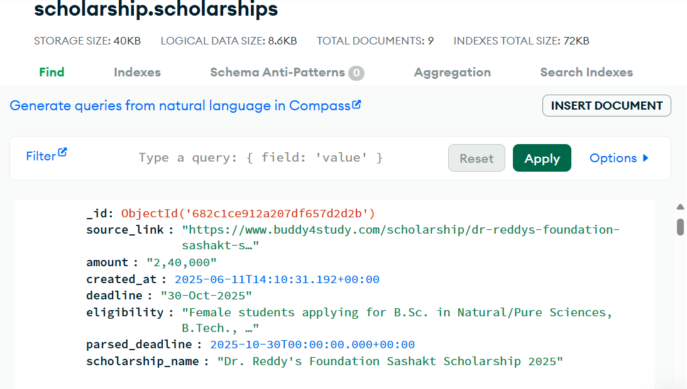

Figure 10.1.a: Data Successfully store in the database

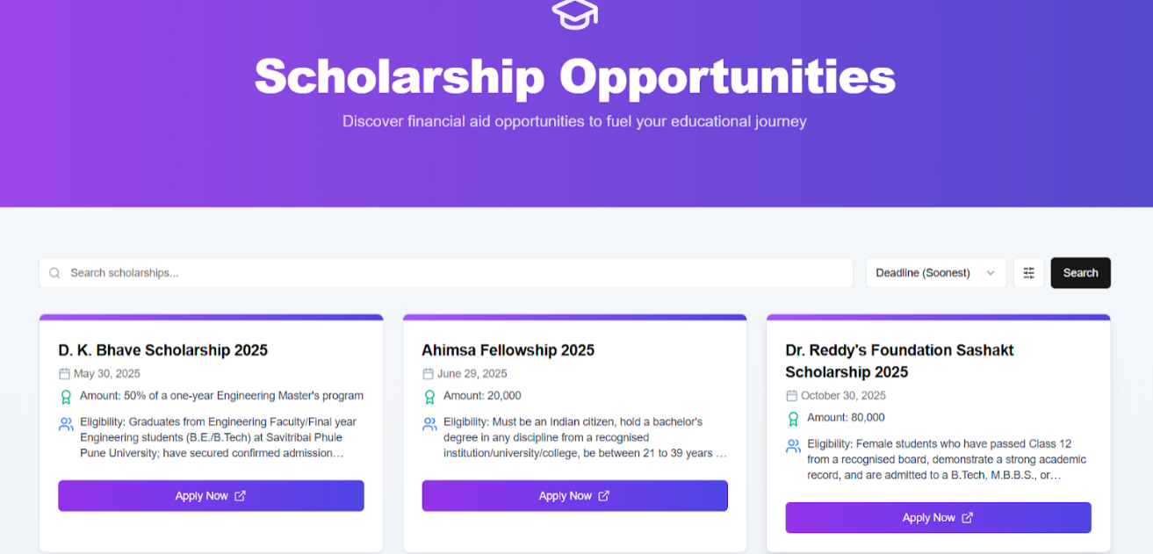

Figure 10.1.b Scholarship Platform UI

**10.1.2 Previous year Question Paper Analyser**

The PYQ Analyzer module was tested with various past year question papers across different subjects. The system successfully extracted unit-wise important topics and identified frequently asked questions by leveraging the Gemini 1.5 Flash LLM.

#### Key Results:

* Accurately identified repeated questions and high-weightage topics.
* Returned structured, unit-wise outputs aligned with standard academic syllabi.
* Allowed users to interact via a chat-like interface to ask follow-up queries (e.g., “Which topic appeared the most in Unit 2?”).
* Maintained low latency with results delivered in under 5 seconds on average.

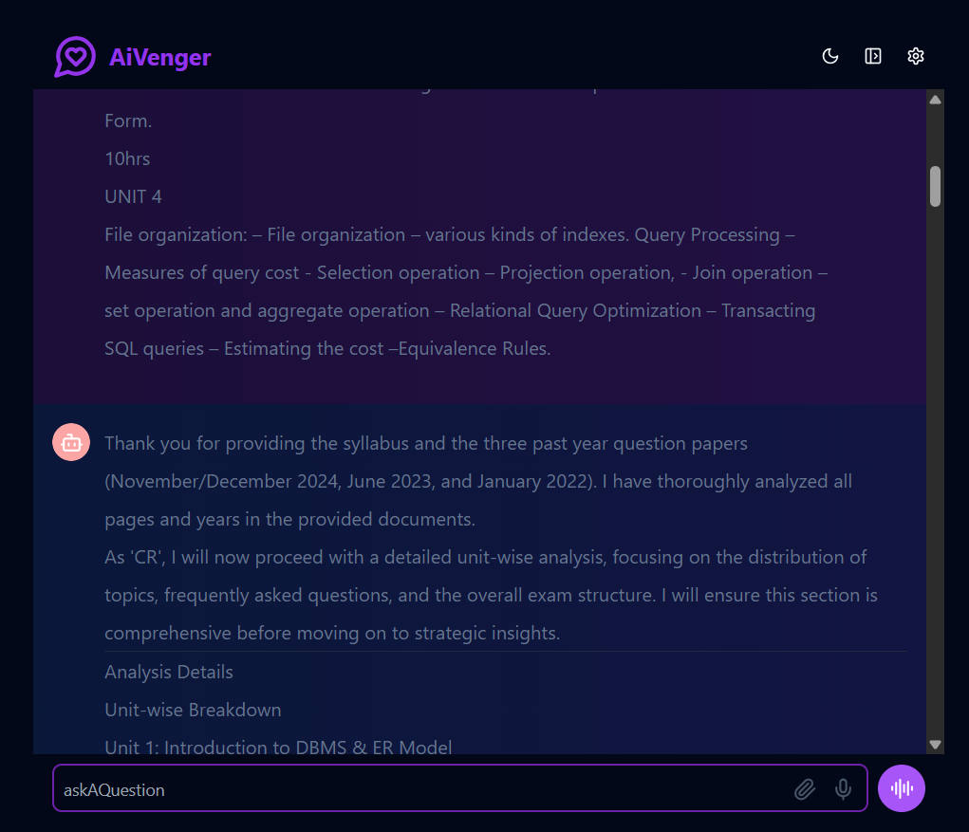

Figure 10.1.c Previous Year Question Paper Analyser UI

**10.1.3 AI Note-Making**

Contextual Accuracy: The notes were grounded in actual textbook content retrieved using FAISS-based similarity search. This ensured alignment with prescribed syllabus topics and significantly reduced the likelihood of hallucinated or off-topic content.

Semantic Quality: The generated notes were evaluated using BERTScore against reference textbook segments. The system achieved an average F1 score 0.83, indicating a high level of semantic similarity and thematic consistency.

Structural Coherence: The use of LLM-assisted semantic chunking resulted in thematically cohesive input segments, enabling the language model to produce logically organized and well-structured notes suitable for academic use.

User Effort Reduction: The system required minimal user input—limited to subject and topic selection—while automating the tasks of text extraction, chunking, context retrieval, and summarization. This significantly reduced manual effort and improved usability.

System Performance and Scalability: The backend, deployed on Hugging Face, efficiently handled processing for multiple textbooks and subjects. The frontend, hosted on Vercel, provided a responsive and accessible interface. The system scaled effectively across textbooks of varying sizes and formats without performance degradation.

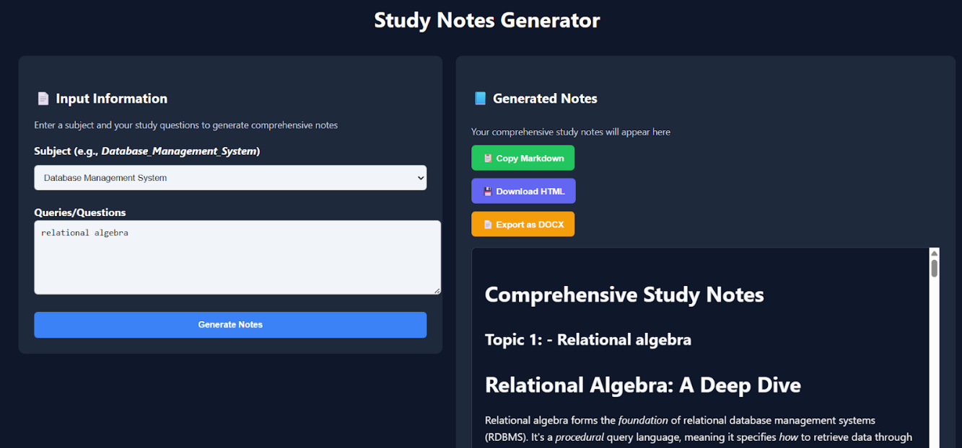

Figure 10.1.d Note Generator Platform UI

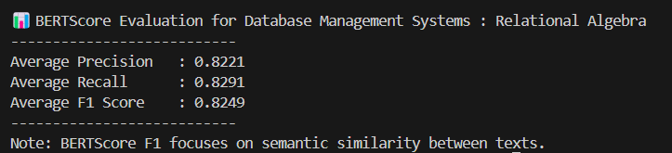

Figure 10.1.e Bert Score for Relational Algebra Notes

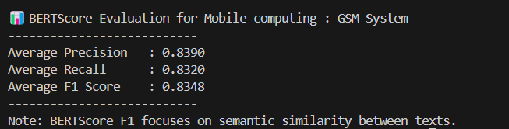

Figure 10.1.f Bert Score for Global System for Mobile Communication Notes

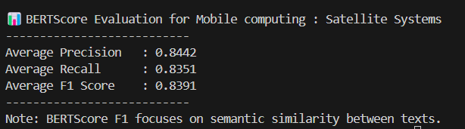

Figure 10.1.g Bert Score for Satellite Systems Notes

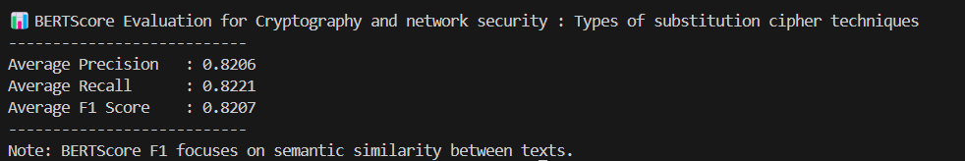

Figure 10.1.h Bert Score for Types of Substitution Cipher Techniques Notes

**10.1.4 AI Skill Gap Analyzer**

The testing phases yielded positive results, demonstrating the core functionalities of the Skill Gap Analyzer.

* Accurate Skill Gap Identification: The system successfully processes user input to understand declared skills, interests, and academic context, forming a basis for identifying potential skill gaps.
* Relevant Course Recommendations: The vector search mechanism implemented with MongoDB proved highly effective. Queries for courses based on specific skills or interests consistently returned semantically relevant learning materials (e.g., asking for "AI ethics courses" correctly suggested courses related to AI and ethical considerations).
* Contextual Project Suggestions: The ProjectSuggestionAgent generated creative and relevant project ideas tailored to the user's profile and stated interests. The ability to store and retrieve these suggestions in the session state allowed for follow-up analysis.
* Effective GitHub Code Analysis: The GitHubAnalysisAgent successfully analyzed provided GitHub repository content, offering constructive feedback, identifying skill gaps in the submitted code, and providing specific suggestions for improvement, including code examples where applicable.
* Reliable External Tool Integration: The system seamlessly integrated with YouTube for video searches, Cloudinary for roadmap image retrieval, and Google Search for general queries, expanding its knowledge base beyond internal data.
* Persistent User Context: The DatabaseSessionService (via NeonDB) successfully maintained user profiles and conversational context across multiple interactions, enabling a personalized and continuous user experience.
* Good Conversational Flow: The ADK's PlanReActPlanner and carefully crafted agent instructions generally resulted in coherent and logical conversation turns, with agents effectively deciding when to use tools or generate direct responses.

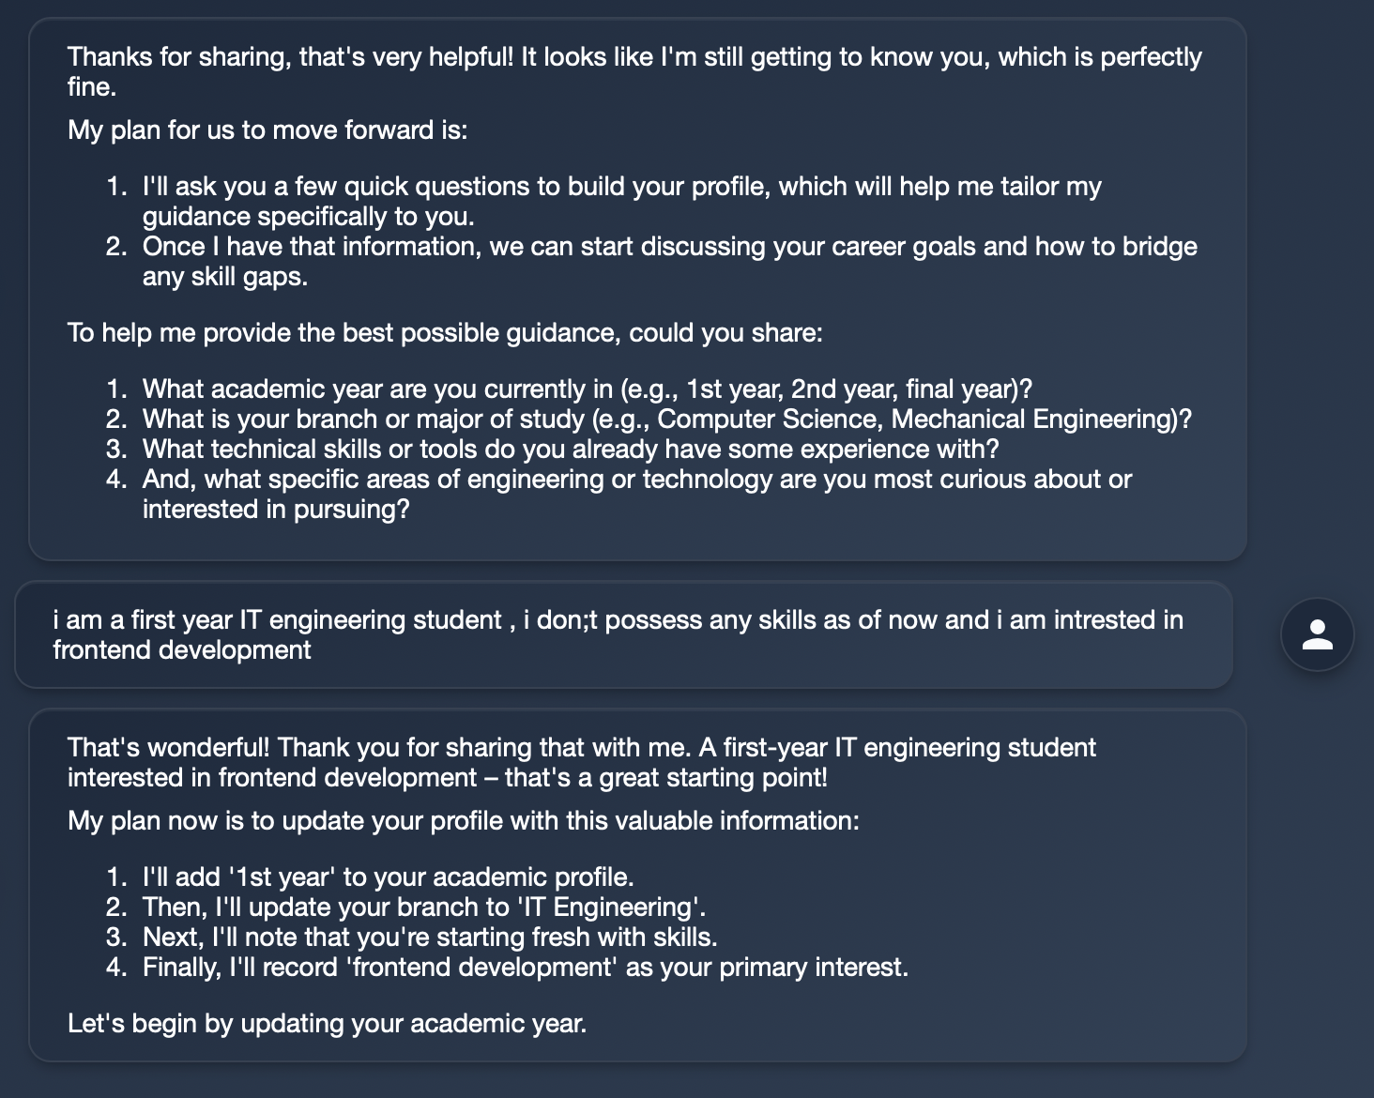

Figure 10.1.i: Initial queries for identifying skill gap

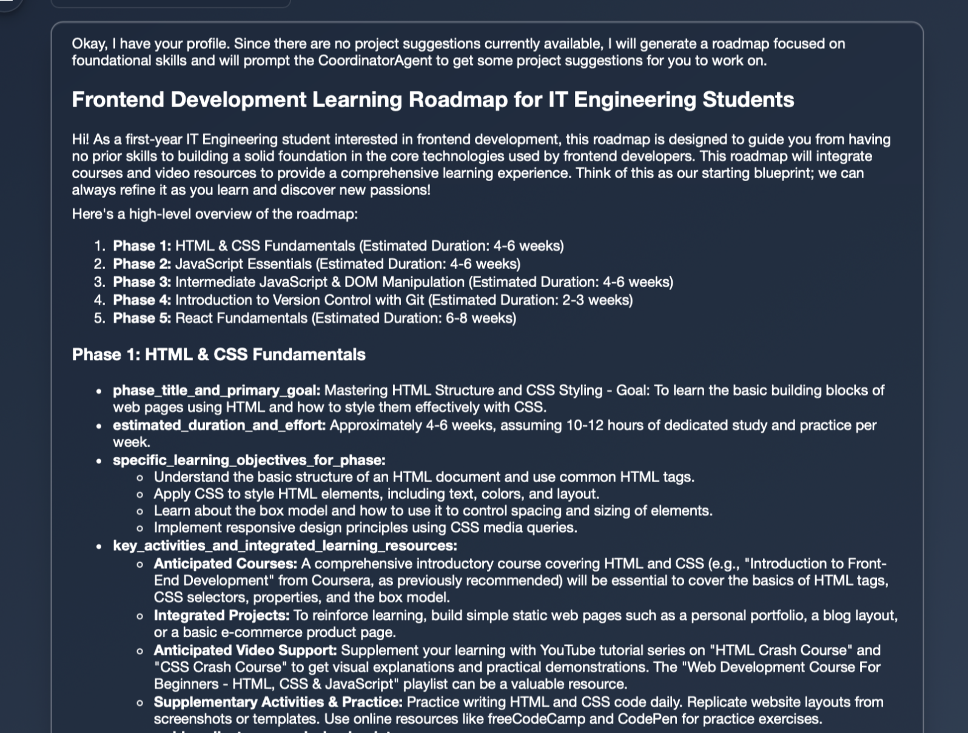

Figure 10.1.j: Successful roadmap suggestion

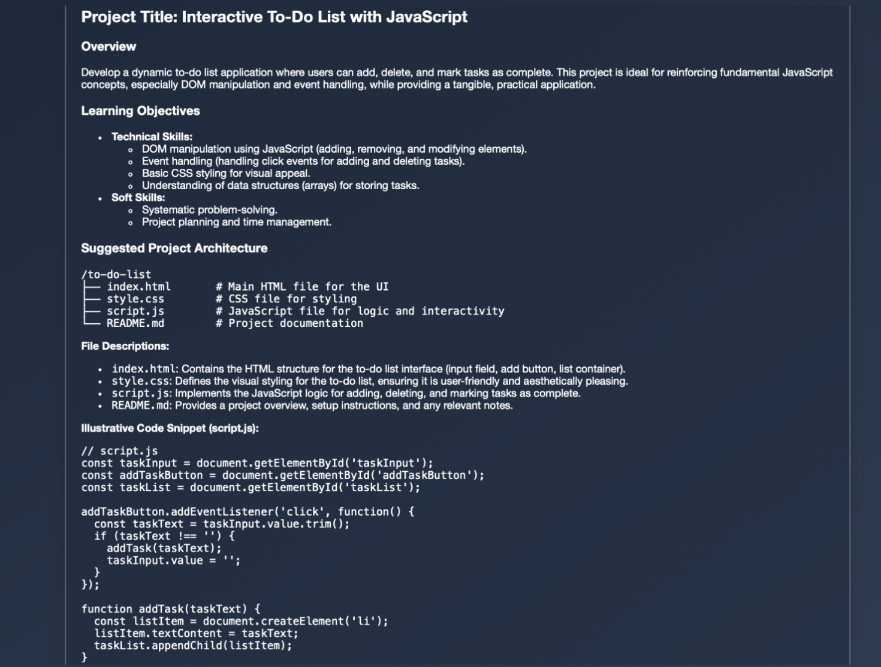

Figure 10.1.k: Successful Project suggestion

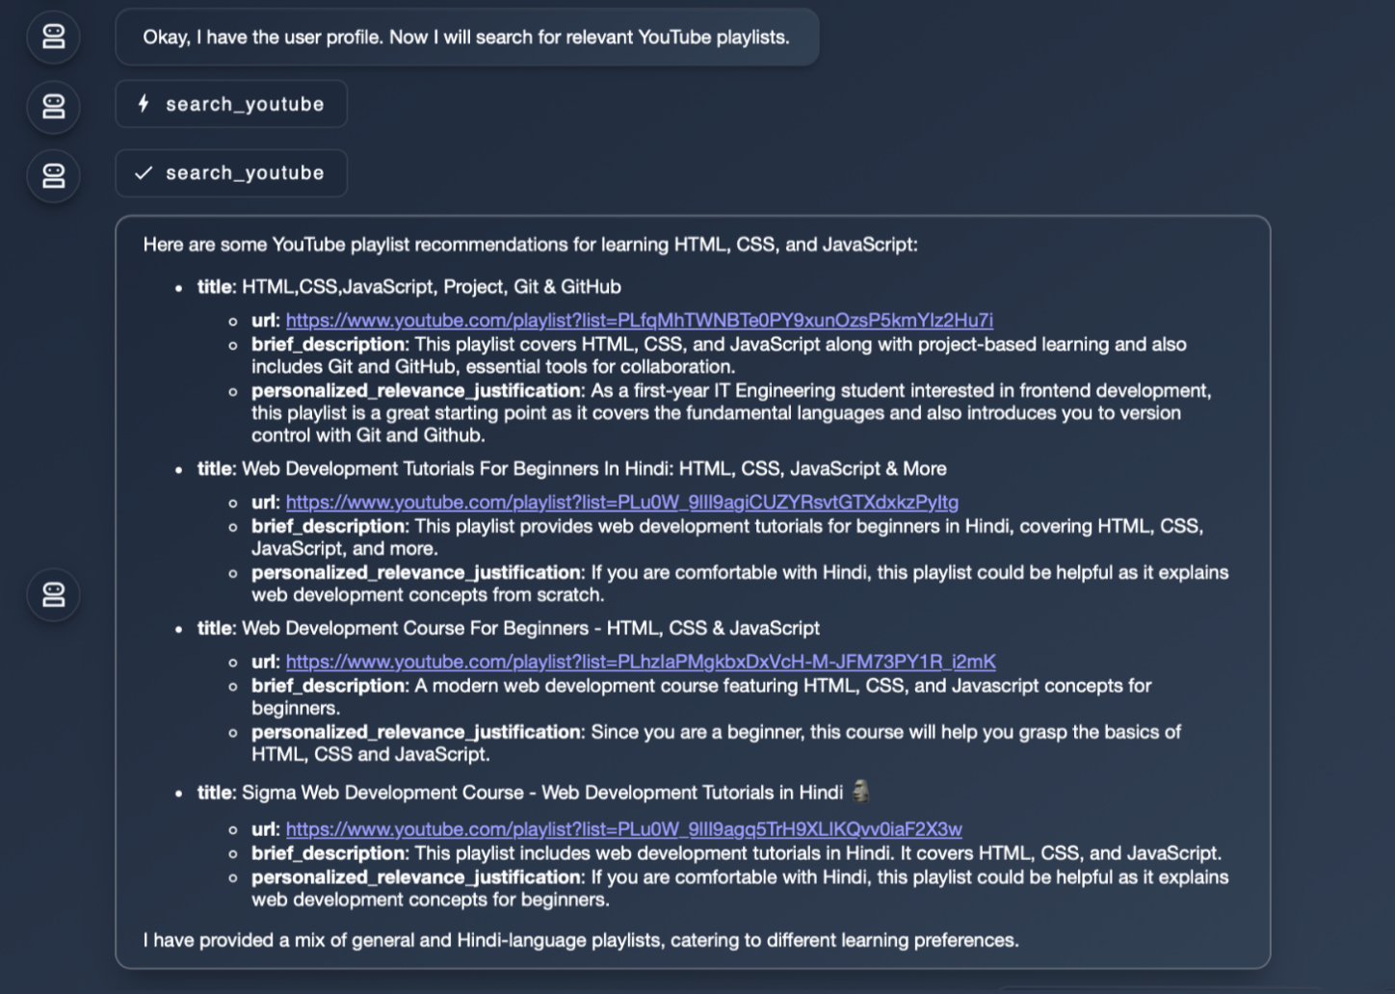

Figure 10.1.l: Successful youtube videos suggestion

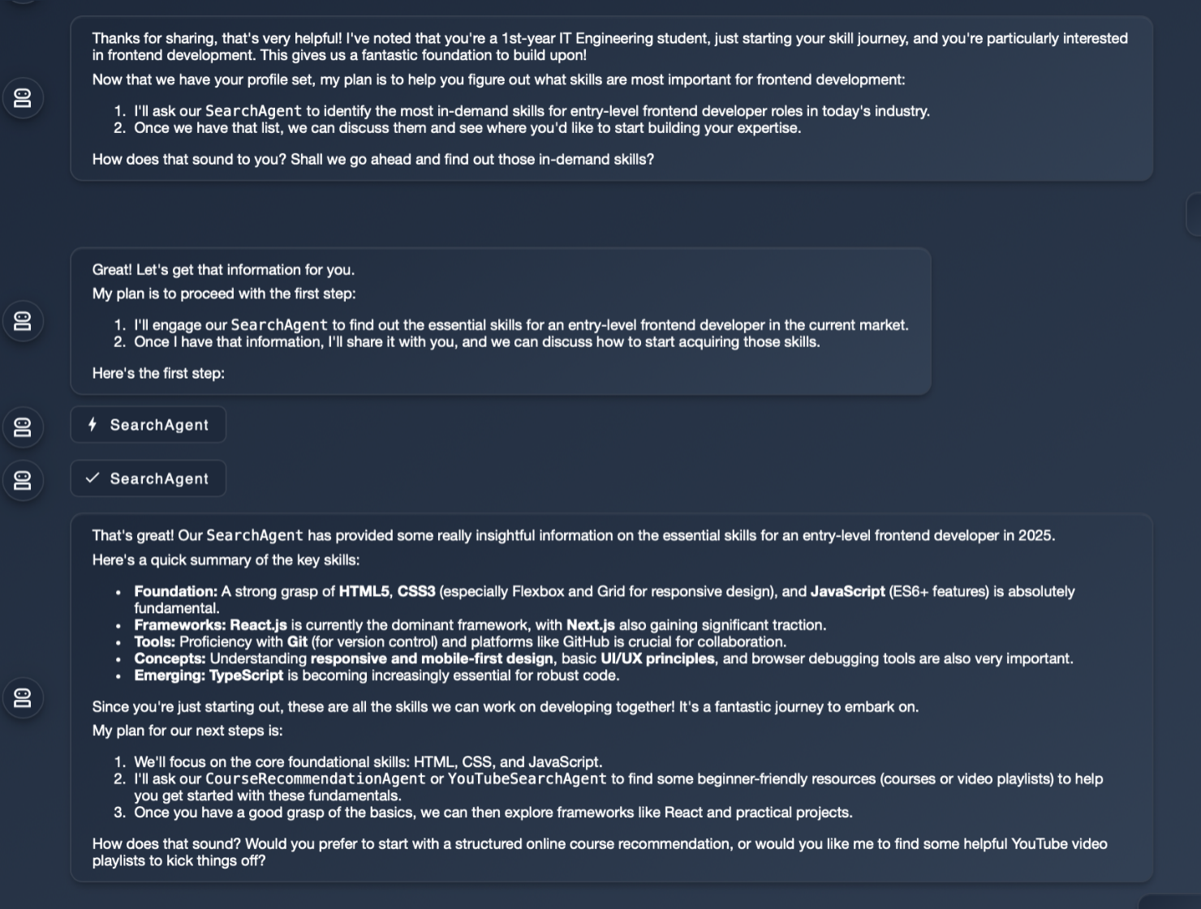

Figure 10.1.m: Successful Google search

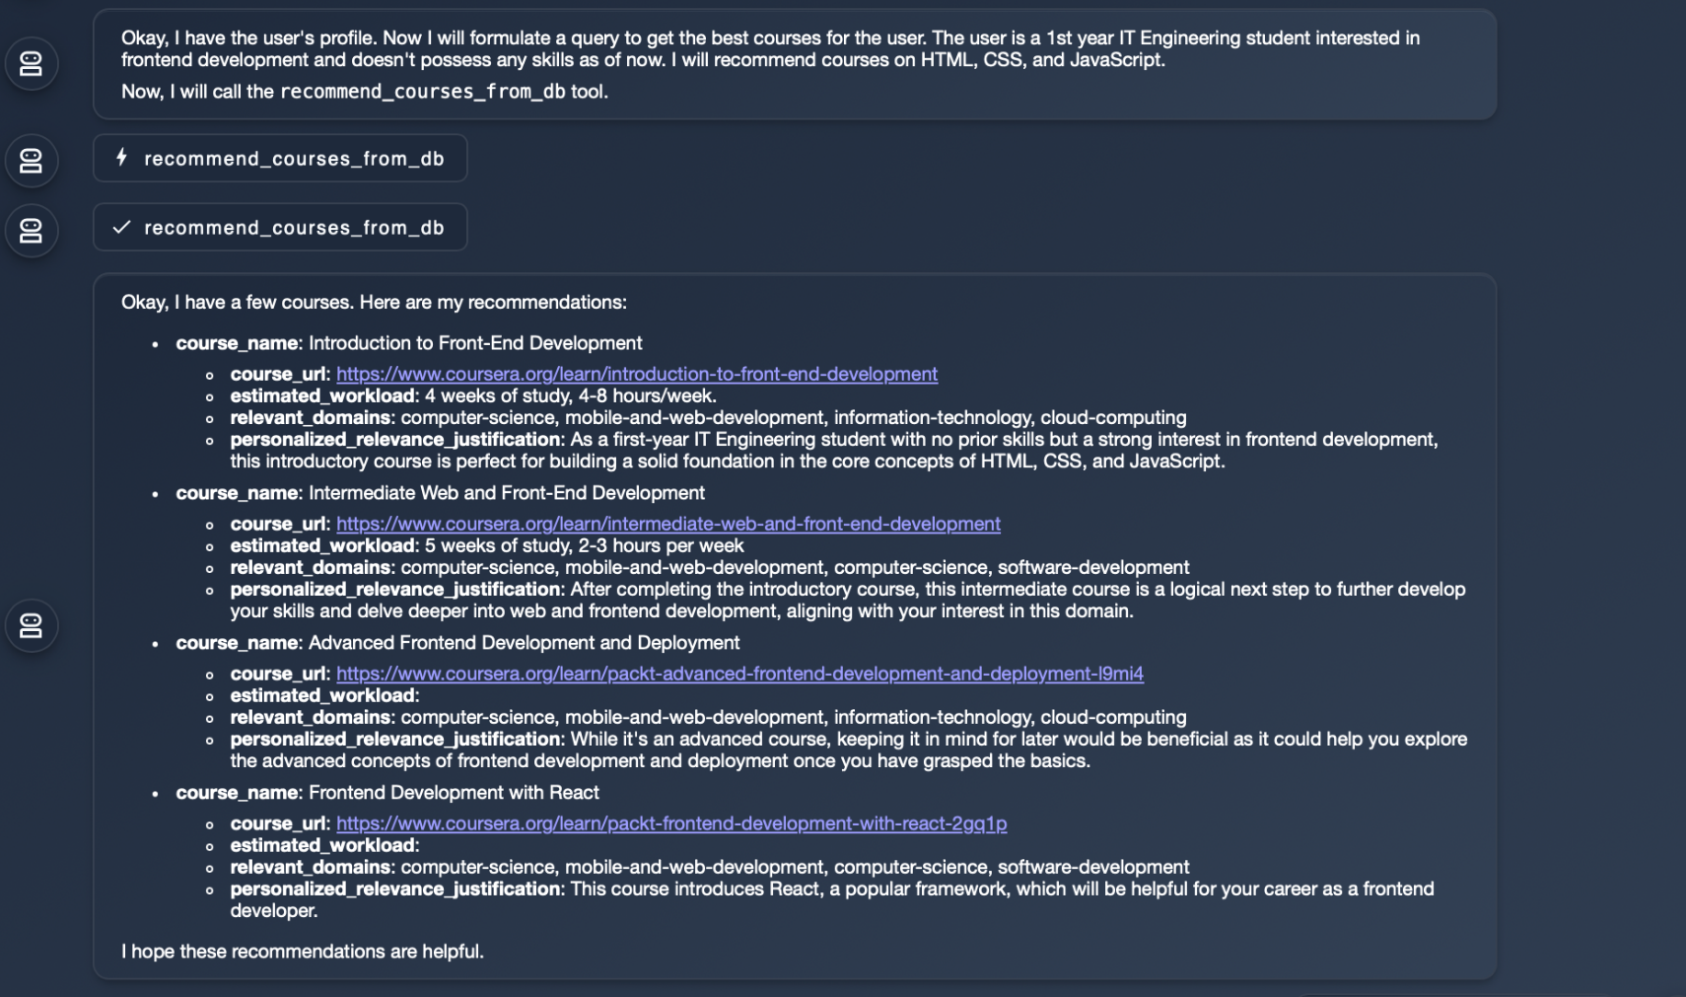

Figure 10.1.n: Successful courses suggestion

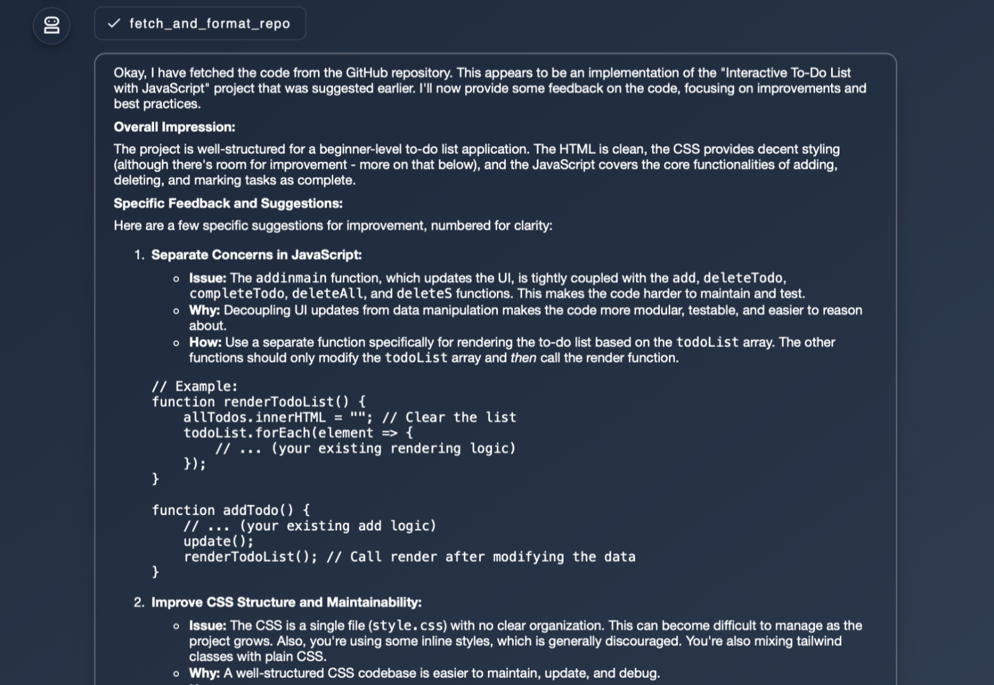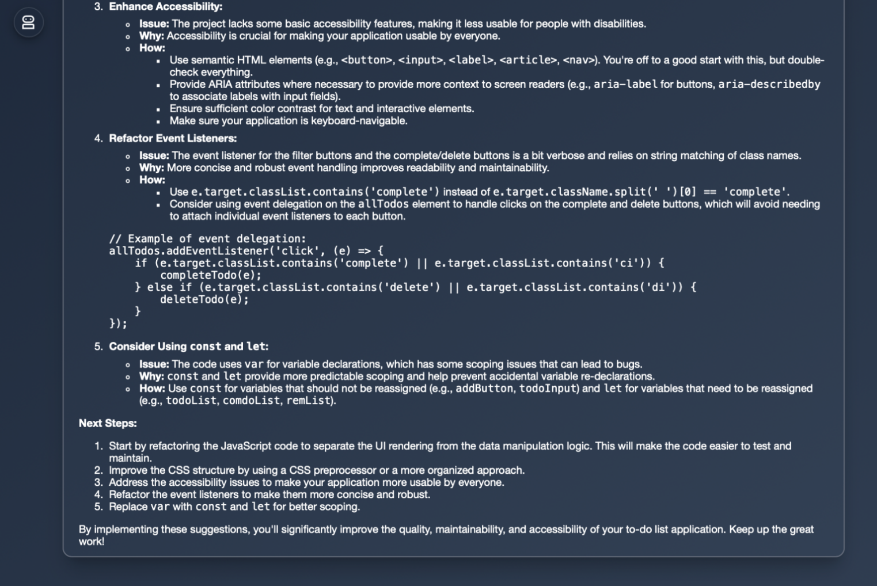Figure 10.1.o: Successful project analyses

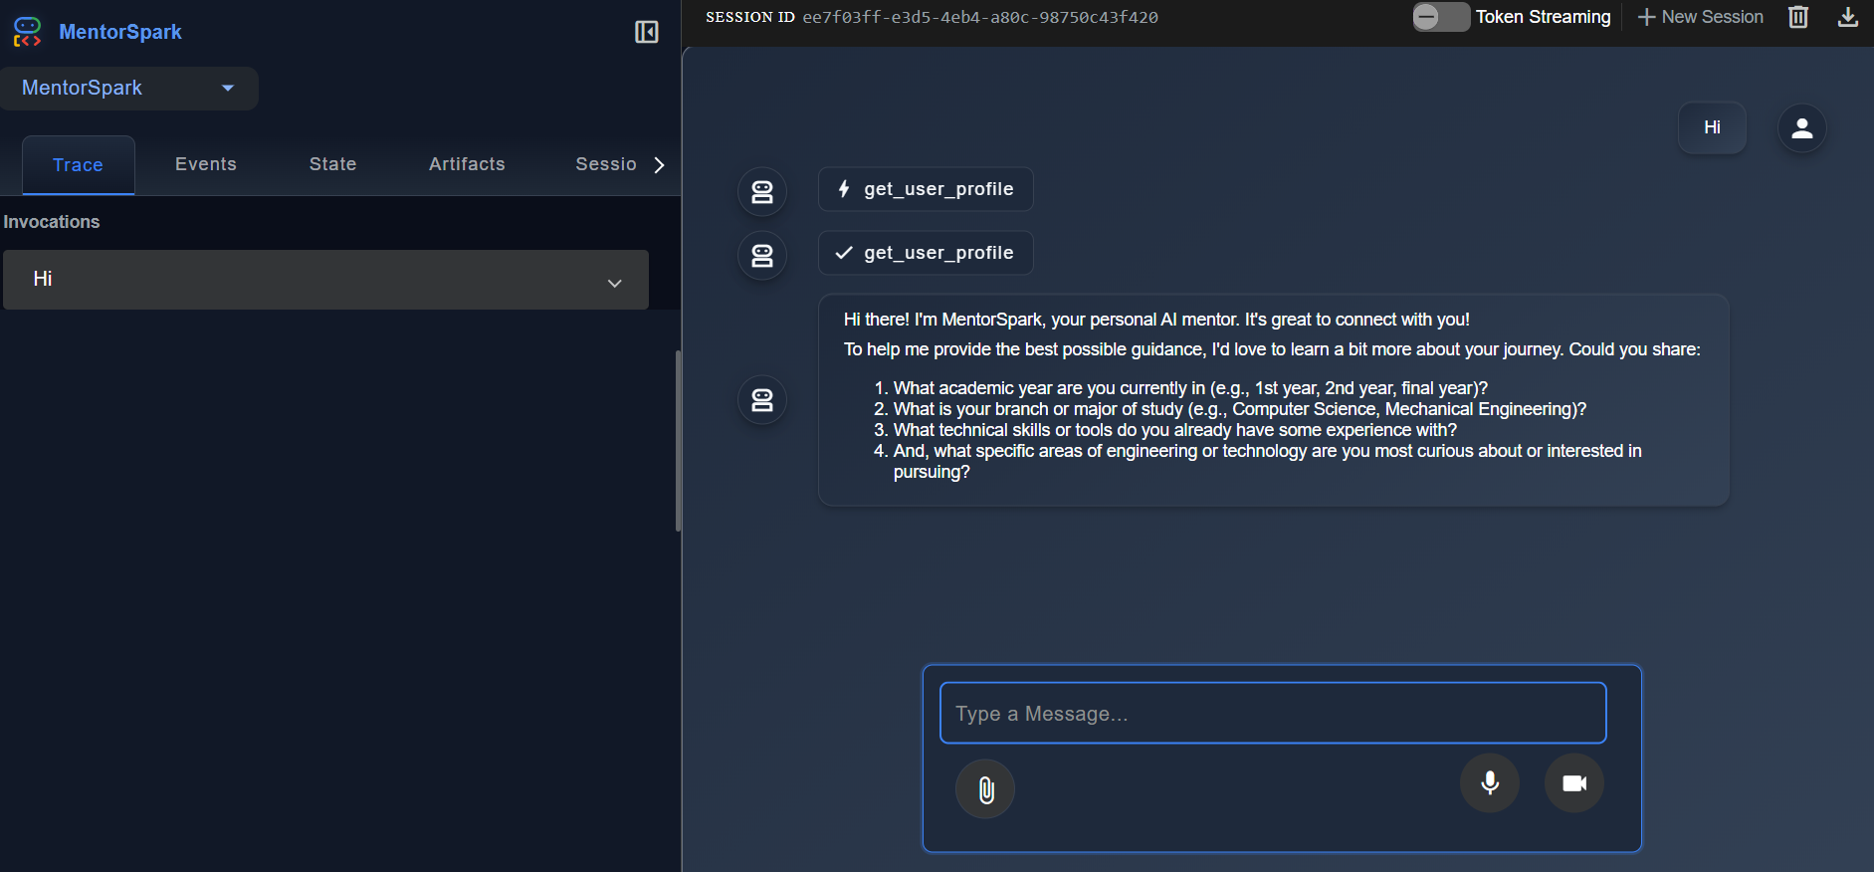

Figure 10.1.p: Skill Gap Analyser UI

**10.2 OBSERVATION:**

**10.2.1 Scholarship Platform**

Several key observations were made during the platform's development and operation:

* AI-driven Scraping Effectiveness: ScrapegraphAI (using Gemini LLM) proved highly adaptable to varying website layouts, significantly simplifying data extraction compared to rigid traditional methods. However, fine-tuning prompts was crucial, and occasional LLM misinterpretations required review.
* Date Parsing Complexity: The wide variety of date formats across different web pages posed a notable challenge, which was largely mitigated by the robust multi-format parse_date_string function.
* Web Scraping Resilience: While largely successful, dynamic content and potential anti-scraping measures necessitated continuous monitoring and logging of failed attempts.
* Automation Reliability: GitHub Actions demonstrated high reliability for scheduled task execution, providing robust environment management and clear logging for operational oversight.

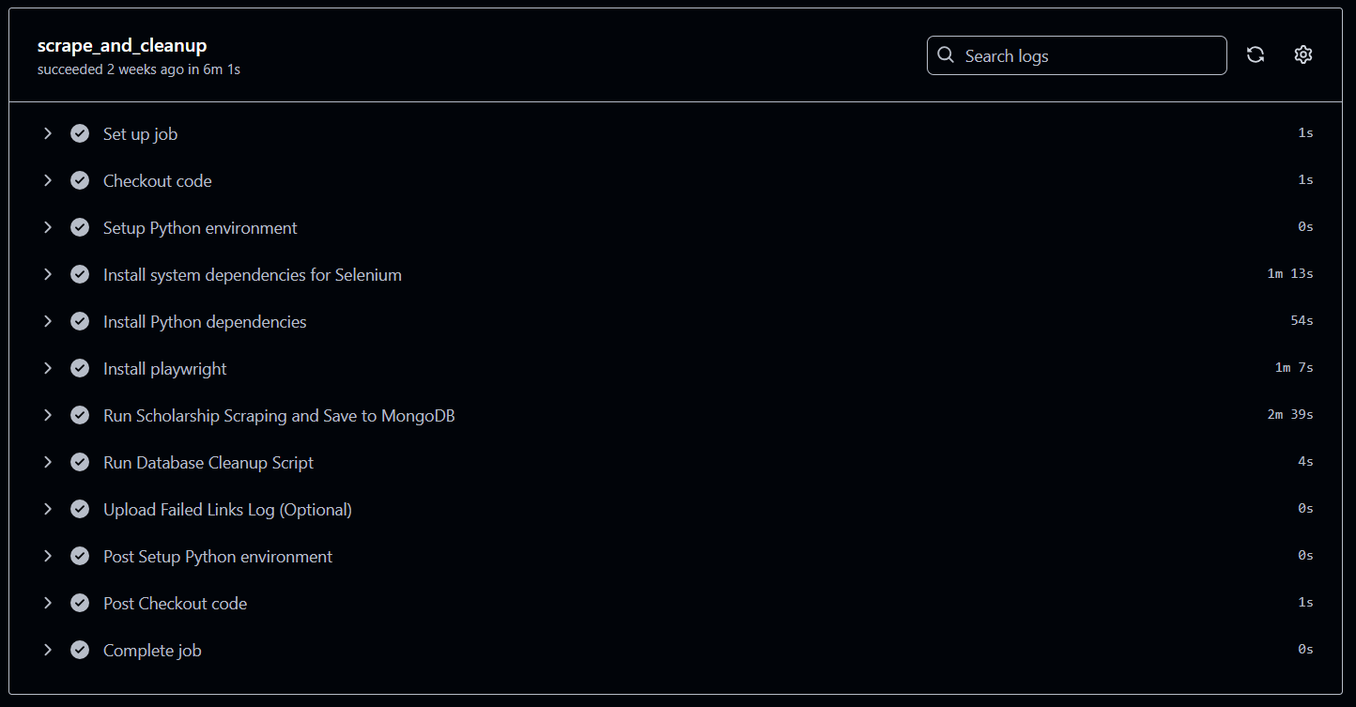

Figure 10.2.a: Successful GitHub Actions workflow run

**10.2.2 Previous Year Question Paper Analyser**

LLM Relevance: Gemini 1.5 Flash showed high understanding of academic structure. Its ability to group questions under units was highly accurate even without explicit unit labels.

Prompt Sensitivity: Small changes in prompt wording slightly affected output structure. Prompt engineering played a key role in ensuring consistent and concise responses.

File Format Dependency: System worked best with clean, well-formatted PDFs. Scanned or image-based PDFs would require OCR integration in the future.

User Experience: The chat-based UI provided an intuitive interface and encouraged iterative exploration of question paper content.

Scalability: Cloudflare deployment handled multiple test uploads without performance degradation.

**10.2.3 AI Note-Making**

Clean and consistent text extraction was crucial to ensure the quality of downstream processing and note generation.Recursive token-based chunking was necessary to handle large textbook inputs due to LLM token limitations.

The quality of generated notes was directly influenced by the thematic clarity of the input chunks.Gemini API rate limits required the implementation of checkpointing and retry logic for reliable long-running operations.

FAISS enabled fast and scalable vector-based retrieval across subjects and textbooks.While diagram extraction was not included, the system successfully generated Mermaid.js-compatible flowchart code, suggesting future visual expansion.

The project benefited from smooth deployment, with the backend hosted on Hugging Face and the frontend on Vercel, supporting a responsive user experience

**10.2.4 AI Skill Gap Analyzer**

During development and testing, several key observations were made:

* LLM Hallucinations and Prompt Engineering: While powerful, LLMs sometimes "hallucinate" or provide factually incorrect information. Extensive prompt engineering for each agent's instruction was crucial to minimize this and steer the agents towards desired behaviors and tool usage. Iterative refinement of prompts was a significant part of the development process.
* Tool Reliability is Key: The overall system's accuracy is heavily dependent on the reliability of the tools it uses. Issues with external API rate limits, network connectivity, or database performance directly impacted the agent's ability to provide a complete response.
* Cost Considerations: Frequent API calls to LLMs and embedding models can incur costs. Optimizing the number of tokens used per interaction and carefully managing API usage was observed as an important factor for scalability and cost-efficiency.
* Context Window Management: For longer conversations, managing the LLM's context window is essential. The ADK's session management helps, but designing agents to summarize or retrieve only necessary past information becomes critical for efficiency and avoiding token limits.
* Data Freshness for Recommendations: The quality of course recommendations is directly tied to the freshness and comprehensiveness of the MongoDB course dataset. Keeping this dataset updated with the latest courses and their embeddings is vital.
* User Expectations: Users often expect immediate and perfect responses from AI. Setting appropriate expectations and providing graceful error handling (e.g., "I couldn't find that, please try again") is important for user satisfaction.
* Scalability of Vector Search: The choice of MongoDB's vector search index demonstrated good scalability for handling increasing numbers of courses, a critical factor for expanding the system's knowledge base.

**10.3 FUTURE SCOPE:**

**10.3.1 Scholarship Platform**

Based on the current implementation, several areas offer significant potential for future enhancement:

* Expand Sources: Integrate more national and international scholarship portals.
* Advanced Extraction: Extract more granular details like application instructions, required documents, or specific course/region eligibility. Explore OCR for image-based data.
* User Interface: Develop a user-friendly web or mobile application for students to search, filter, and apply for scholarships.
* Notification System: Implement email/SMS alerts for new relevant scholarships or upcoming deadlines.
* Recommendation Engine: Develop AI-powered recommendations to match students with scholarships based on their profile.
* Enhanced Resilience: Implement more sophisticated retry mechanisms, proxy rotation, and real-time monitoring dashboards for scraping operations.

**10.3.2 Previous Year Question Paper Analyser**

The PYQ Analyzer module has strong potential for further enhancement. Future improvements may include:

* Multi-Year Analysis: Allow uploading multiple question papers to detect long-term trends and frequently repeated topics.
* OCR Integration: Enable support for scanned or image-based question papers using OCR technologies.
* Topic Summarization: Use AI to provide brief explanations and learning resources for important topics.
* Graphical Output: Display topic frequency and unit-wise weightage using charts and graphs for better visualization.
* Multilingual Support: Extend functionality to regional languages to serve a wider user base.
* Syllabus Comparison: Highlight gaps between syllabus and past papers to improve preparation focus.
* User Dashboard: Track uploads, bookmarked topics, and personalized insights.
* Module Integration: Seamlessly connect with other platform modules like AI Note-Maker and Skill Gap Analyzer.

**10.3.3 AI Note-Making**

### 1. Multimodal Notes Generation

The system can be extended to include images, diagrams, and charts extracted from textbooks. By embedding and retrieving image content alongside text chunks, future versions could generate visually enriched notes that enhance conceptual understanding, particularly in subjects like science and engineering.

### 2. Interactive Learning Mode

The note generator could be integrated with an interactive Q&A module, allowing users to ask follow-up questions or request deeper explanations of specific concepts within the generated notes. This would turn the system into an active learning assistant rather than just a static summarizer.

### 3. Support for More Languages

Currently, the system is designed for English-language textbooks. Adding support for regional and international languages would make the tool accessible to a broader academic audience, particularly in multilingual education systems.

### 4. Curriculum and Exam Pattern Alignment

Future versions could incorporate university-specific syllabus mapping, enabling the system to tag and prioritize topics based on exam weightage or previous year questions (PYQs). This would help students focus on high-priority content areas.

### 5. Personalized Learning Paths

By tracking user interaction, learning history, or performance on quizzes, the system could generate personalized study plans and notes tailored to the learner’s weak areas or goals, offering a more customized academic experience

**10.3.4 AI Skill Gap Analyzer**

The Skill Gap Analyzer, while functional, has significant potential for future enhancements and expansion:

1. Enhanced Personalization and Adaptive Learning Paths:
   * Integrate more sophisticated user profiling, including learning styles, preferred content formats, and progress tracking from external learning platforms (e.g., Coursera, Udemy APIs).
   * Develop an adaptive learning module that dynamically adjusts the difficulty and type of recommended resources based on a user's demonstrated progress and identified learning gaps.
   * Implement skill tree/graph visualization to graphically represent a user's current skills, target skills, and the shortest learning paths to bridge gaps.
2. Proactive Skill Gap Prediction:
   * Develop a module that, based on industry trends, job market data (e.g., scraping job portals), and a user's career aspirations, proactively suggests emerging skills they should acquire to stay relevant.
   * Predict potential future skill gaps for users who haven't explicitly asked for them, providing timely recommendations.
3. Advanced Project Management and Collaboration:
   * Allow users to track their progress on suggested projects within the analyzer.
   * Integrate with version control systems (beyond basic GitHub analysis) for more in-depth code reviews, automated testing suggestions, and collaborative learning features.
   * Enable multi-user collaboration features where teams can identify collective skill gaps and shared learning goals.
4. Broader Content Integration:
   * Expand beyond YouTube and general courses to include integration with textbooks, research papers, interactive tutorials, and coding challenges.
   * Leverage more diverse embedding models for multimodal content (e.g., code, images, audio) to broaden the scope of analyzable content.
5. Gamification and Motivation:
   * Incorporate gamified elements such as badges, progress bars, and leaderboards to motivate users to engage with learning resources and close skill gaps.
   * Implement a reward system for completing courses or projects.
6. Multi-language Support:
   * Extend the system to support multiple languages, leveraging Gemini's multilingual capabilities for both conversational input and content recommendations.

**Chapter 11**

**Conclusion**

The AI-Powered Student Enhancement Platform represents a significant step forward in utilizing artificial intelligence to improve academic performance, skill development, and access to educational opportunities.

The system is composed of four interdependent yet independently functional modules:

* Previous Year Question Paper Analyser: Leverages Gemini 1.5 Flash to analyze past question papers, uncovering repeated patterns and extracting unit-wise important questions. This provides students with focused preparation strategies based on actual exam trends.
* AI Note-Making: Uses LangChain and FAISS to retrieve relevant textbook content and generate structured, syllabus-aligned notes. This reduces the manual effort of note preparation and enhances content relevance and retention.
* Skill Gap Analyzer: Built using Google Agent Development Kit (ADK), this module creates autonomous agents that assess students' current skill levels and suggest personalized learning paths, resources, and career-aligned courses.
* Scholarship Recommendation: Utilizes BeautifulSoup to scrape real-time data on scholarships and filters them according to the student's academic profile, category, and interests, ensuring broader access to financial aid.

Each module has been developed and deployed independently to ensure modularity, fault isolation, and ease of maintenance, while the centralized interface links them seamlessly to deliver a holistic user experience.

The integration of cutting-edge technologies—such as LLMs (Gemini), LangChain, vector databases (FAISS), autonomous agents (ADK), and intelligent scraping—proves that AI can be meaningfully applied to real educational challenges. The platform not only automates repetitive academic tasks but also empowers students with data-driven guidance and personalized insights.

This project serves as a strong foundation for future expansion, including deeper cross-module integration, multi-language support, and a personalized learning dashboard. In conclusion, the AI-Powered Student Enhancement Platform holds immense potential to revolutionize how students learn, prepare, upskill, and access opportunities in a rapidly evolving educational landscape.

**Chapter 12**

**Bibliography**

[**https://ieeexplore.ieee.org/document/10574972**](https://ieeexplore.ieee.org/document/10574972)

[**https://ieeexplore.ieee.org/document/10499105**](https://ieeexplore.ieee.org/document/10499105)

[**https://ieeexplore.ieee.org/document/10544643**](https://ieeexplore.ieee.org/document/10544643)

[**https://ieeexplore.ieee.org/document/10336211**](https://ieeexplore.ieee.org/document/10336211)